You Say You Want a Revolution
  - By Saul Straussman, Big History Project, adapted by Newsela staff

In the 1600s and 1700s, several events combined to change the lives of people around the world. The Age of Exploration brought many new goods from eastern Asia to Europe. Goods also moved from the Americas to Africa, Europe and Asia. People and things were moving around the globe faster than ever before. It wasn’t just people and things moving, though. New ideas were also flowing over the globe.
During the Age of Exploration, Europeans began to colonize other parts of the world. At the same time, Enlightenment thinkers started to question the idea of liberty. They were thinking about what “liberty” actually meant. For some Enlightenment thinkers, liberty meant popular sovereignty.
Popular sovereignty is the idea that the people of a country need to support the government in order for the government to be legal. Think about that for a moment. In the 1700s, almost all of the governments in the world were ruled by kings and queens. Nobody voted for who would be king. The people did not have a say.
Where did this idea of liberty or popular sovereignty come from?
English philosopher John Locke (1632-1704) is famous for his idea of liberty. Locke believed that “All people have the natural rights of life, liberty, and property.”
Let’s break down Locke’s statement. Locke believed that once we’re born, we have the right to a good life. He also said that we are all equal. Finally, he said that we have a right to keep our own money and possessions (property). No government can take these away from us.
Locke explained the purpose of any government: “The power of government comes from the people and the duty of the government therefore is to protect those natural rights.”
In other words, the three natural rights we have — life, liberty, and property — should be protected by a government.
What if the government fails to do that? According to Locke, “then the people have the right to overthrow the government, by force if necessary.”
Wow! Imagine you are a king in that time. Locke’s ideas would be rebellious. If people took these ideas seriously, they might even start a revolution!

Causes of revolution in the Atlantic world
The Enlightenment thinkers had been expressing these ideas for a long time, but they were just talked about. Now, events in Europe and the Americas led people to question their governments. People had a reason to put finally those ideas into action.
The Seven Years' War in Europe was known in North America as the French and Indian War. It is one major event that led to revolutions around the world.
In the Seven Years' War, Great Britain defeated France. As a result, Britain gained all of France’s territories in Canada and India. The British won, but they owed money from the war.
Great Britain had to pay back what they owed. To do it they made the American colonists pay for the war. The colonists benefited from the victory, because the new territory made them safer. How would the colonists pay for the war? Taxes.
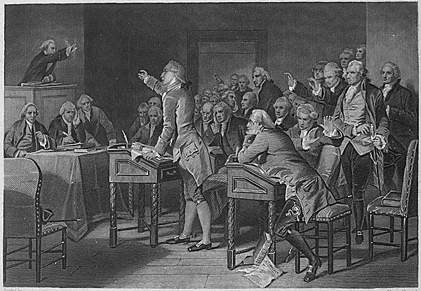Taxes were a common reason for revolutions between 1775 and 1830. High taxes made people angry. That anger combined with the ideas of Enlightenment thinkers who gave reasons for getting rid of ruling governments and their taxes.
To help pay for the Seven Years War, the British government passed the Stamp Act. This was a tax on goods in the Americas to help pay for “the expenses of defending, protecting, and securing” the American Colonies. The tax was known as the Stamp Act because the government put a stamp on items to prove that the tax had been paid on them.
Patrick Henry was an American colonist who did not like the new taxes. He gave a famous speech to the Virginia Convention on March 23, 1775. He said the American colonists had asked Great Britain for lower taxes, but they were rejected. He ended with a famous line: “give me liberty or give me death!”
Henry and others thought the British government was ignoring the colonists while still ruling over them. According to Locke’s ideas, the colonists were now free to throw off this government. What does this mean? Revolution!

Revolution in France ...
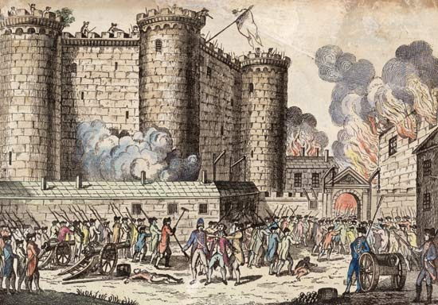Across the Atlantic in France, a similar situation happened a few years later. The French people were also being forced to pay for France’s debts from the Seven Years War. France also owed money from its support of the American Revolution.
At this time, French society was divided up into three big groups. The first were the religious leaders, and the second included the rich nobles. The third group was made up of everyone else, basically the common people.
Together, the rich and religious leaders were only about 3 percent of the population. That means the common people made up 97 percent of the population.
The rich and religious leaders did not have to pay most of the king’s taxes. This meant the taxes had to be paid by the common people. These were the people who could afford them the least.
Some common people attempted to present their complaints to King Louis XVI in 1789. They wanted what John Locke wrote about: life, liberty, and property.
The king did not know how to deal with them. King Louis XVI was not a strong leader. He was unable to convince the rich to pay some of the taxes.
In the end, Louis was unable to help the common people pay less in taxes. That group now had a reason to revolt.
The French Revolution replaced the king. In his place, they put a National Assembly made up of members of the common people.

And in Saint Domingue, Mexico and Venezuela
It’s fascinating how the idea of liberty changed as it bounced back and forth across the Atlantic. Let's look at the French colony of Saint Domingue (now Haiti).
People on the island were split into three separate groups: whites, gens de couleur libres (free people of mixed European and African ancestry), and slaves. Almost 90 percent of the population were slaves. However, only whites were given French citizenship.
The free people of color made demands to the newly created National Assembly of the French Revolution. The gens de couleur libres used Locke’s ideas to argue for equality. They wanted the same rights as French citizens. Still, they did not fight for the freedom of the slaves.
The idea of liberty continued to change as it traveled throughout the Atlantic world. In Mexico, like Haiti, people began discussing rights for people of mixed heritage. In this case, it was liberty for the mestizos – people of mixed Spanish and native heritage. In 1810, a priest named Miguel Hidalgo y Costilla rallied the people to revolt against Spain’s harsh rule. One of the causes was unfair taxation.
Father Hidalgo’s revolt was unsuccessful, but his ideas fueled more resistance to Spain’s rule in Mexico. In 1821, Mexico finally won its independence from Spain.
Lastly, let’s look at Venezuela. It was another Spanish colony where several groups struggled for liberty. Each group had its own definition of liberty and its own goals.
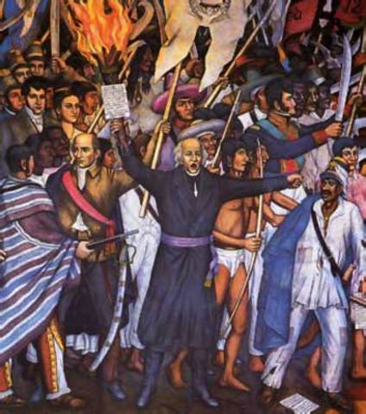In Venezuela, the rich white landowners were split into two groups. One was of people born in Spain. The other was people of Spanish descent born in the Americas, called criollos. Both groups wanted to sell their coffee and cocoa freely instead of being forced to sell their goods only to Spain. Members of the criollos usually worked as artisans, soldiers, and traders. They wanted to have the same opportunities as the wealthier people born in Spain.
Mestizos (people of mixed Spanish and native heritage) made up the largest group within Venezuela. They were generally poor farmers. The mestizos were most interested in ending the privileges enjoyed by the white landowners.
Slaves made up about 20 percent of the population of Venezuela. They, of course, wanted to end slavery. However, they did not have much opportunity to make their voices heard.
A military group took over the country by force, led by Venezuelan revolutionary Simón Bolivar. The group passed many changes:
White landowners could now trade with whoever they wished.
Taxes on food and native people were ended, and so was slavery. All of the different groups achieved the liberty they desired.
We should note that the Venezuelan revolution of 1808 was short-lived. The Spanish monarchy regained control of Venezuela, in 1814. In 1819, Venezuela finally won its independence from Spain. Unfortunately, the slaves did not win their freedom.

Conclusion
The ideas of John Locke and other Enlightenment thinkers of the late 1600s and 1700s released revolutionary ideas that many of the thinkers could not have expected.
The idea of liberty was a powerful force that inspired people on both sides of the Atlantic to reject governments that did not respect their rights.
Not every country was successful in gaining independence. Still, these ideas were spreading. By the beginning of the 1900s, this revolutionary spirit had spread to parts of the Middle East and Asia. In 1909, the last sultan of the Ottoman Empire was exiled after the Young Turk Revolution. After thousands of years of being controlled by emperors, China was overtaken by a nationalist government led by Sun Yat-sen in 1912. Sun’s ideas on liberty and the role of government would influence both the nationalist leader Chiang Kai-shek and the future communist leader of China, Mao Zedong.

