Examining Images
According to the Greek philosopher, Aristotle, people use three different strategies to persuade audience
Ethos | Pathos | Logos
An argument based on the credibility of a character or authority | An argument based on emotions: fear, desire, sympathy, anger, etc. | An argument based on logic: facts and figures

British/American | German | Theme
What method of persuasion is used? 1  Describe aspects of the poster that support this. | What method of persuasion is used? 2  Describe aspects of the poster that support this.
What method of persuasion is used? 3  Describe aspects of the poster that support this. | What method of persuasion is used? 4  Describe aspects of the poster that support this.
What method of persuasion is used? 5  Describe aspects of the poster that support this. | What method of persuasion is used? 6  Describe aspects of the poster that support this.
What method of persuasion is used? 7  Describe aspects of the poster that support this. | What method of persuasion is used? 8  Describe aspects of the poster that support this.

- What patterns do you see in the way governments mobilized their people for war?
- What persuasive strategy did they use the least? Why?

Examining Images
According to the Greek philosopher, Aristotle, people use three different strategies to persuade audience
Ethos | Pathos | Logos
An argument based on the credibility of a character or authority | An argument based on emotions: fear, desire, sympathy, anger, etc. | An argument based on logic: facts and figures

British/American | German | Theme
What method of persuasion is used? 1  Pathos or ethos  Describe aspects of the poster that support this.  Presents the enemy as an evil dragon  Perhaps makes use of St George and the dragon imagery—knight | What method of persuasion is used? 2  Pathos or ethos  Describe aspects of the poster that support this.  Presents the enemy as an wild lion  Perhaps makes use of Hercules’ feats. | Both make use of a mythical conflict between good and evil
What method of persuasion is used? 3  Pathos  Describe aspects of the poster that support this.  Appeal to the traditional role of fathers as protector | What method of persuasion is used? 4  Pathos  Describe aspects of the poster that support this.  Appeal to the traditional role of fathers as protector | Family responsibility was used to convince men to fight.
What method of persuasion is used? 5  Ethos  Describe aspects of the poster that support this.  Kitchner, a war hero, calls men to action | What method of persuasion is used? 6  Ethos  Describe aspects of the poster that support this.  Von Hindenberg, a war hero, calls men to action | War heroes are used to convince people
What method of persuasion is used? 7  Pathos or logos  Describe aspects of the poster that support this.  Germany is presented as a frightening, King-Kong like figure, which depicts German militarism | What method of persuasion is used? 8  Pathos or logos  Describe aspects of the poster that support this.  British imperialism is depicted as a spider taking over the world | While there was some truth to the accusation, the propaganda used frightening images to exaggerate the enemy’s problems.

- What patterns do you see in the way governments mobilized their people for war?
Generally, the propaganda appealed to the emotions and particularly the emotion of fear.
- What persuasive strategy did they use the least? Why?
The propaganda made little to no appeal to logos, probably because people are better persuaded by emotional appeals or the examples of social heroes.

1
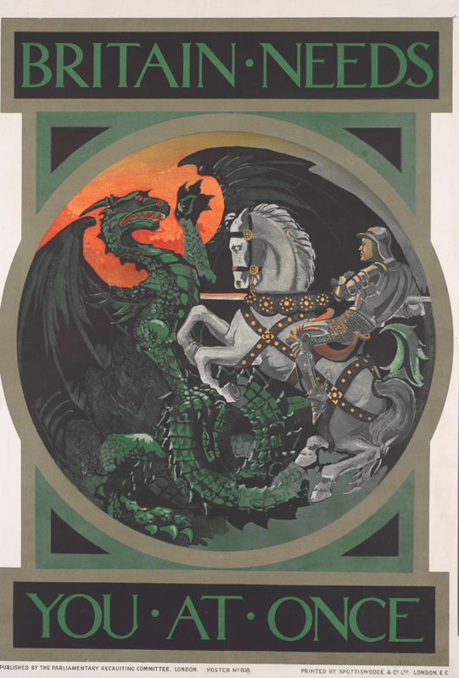
2
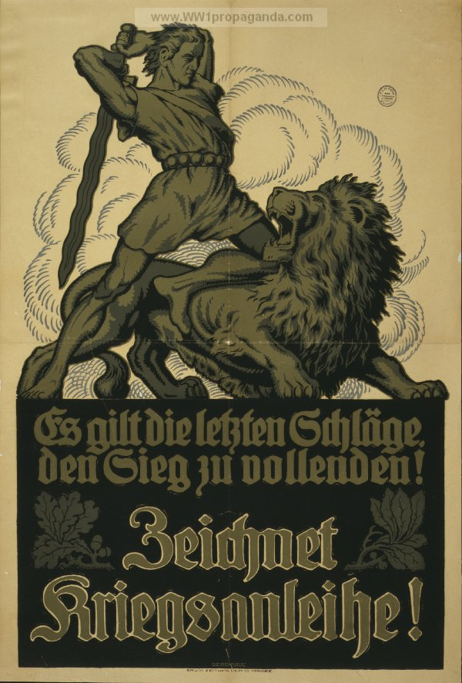
It is the last stroke to complete the victory!
War Bonds!
3
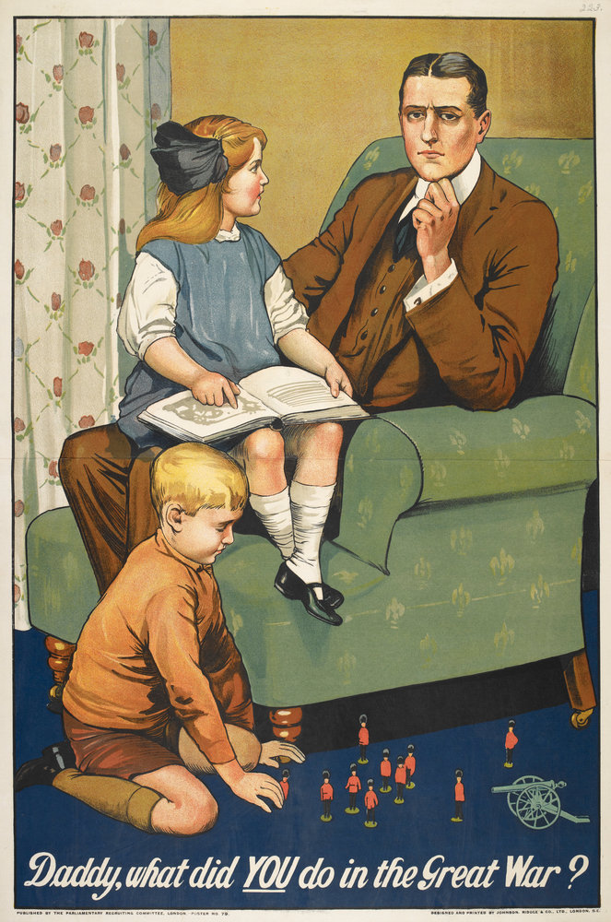
4
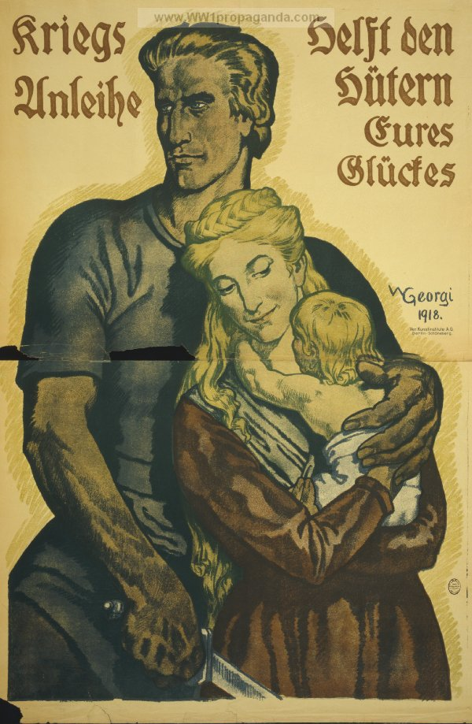
War bonds.
Help the guardians of your happiness
5
Lord Kitchner, famous for his imperial campaigns throughout the empire, became the Secretary of War
6
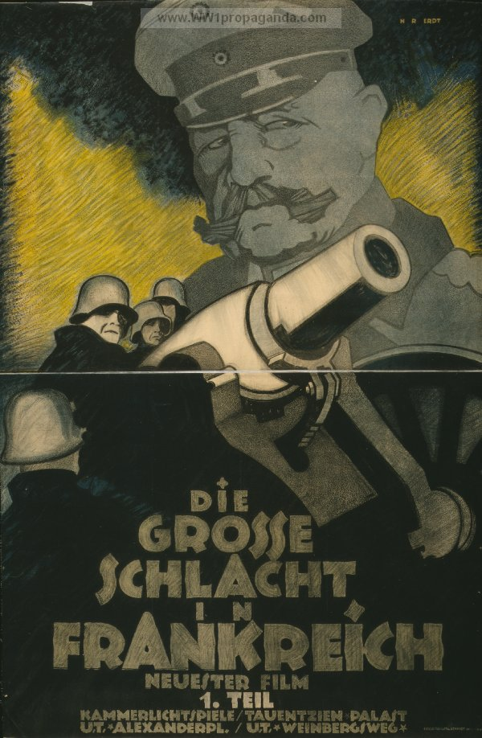
The great battle in France.
(General Paul von Hindenburg, veteran from the Franco-Prussian War who became a hero after his early victories on the Eastern Front.)
7
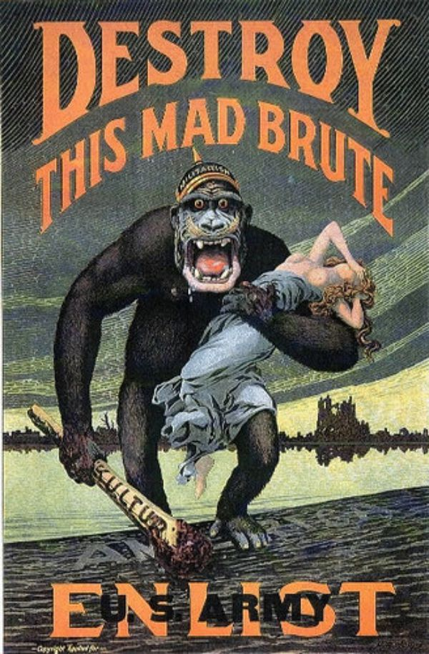
What does this American poster accuse the Germans of?
8
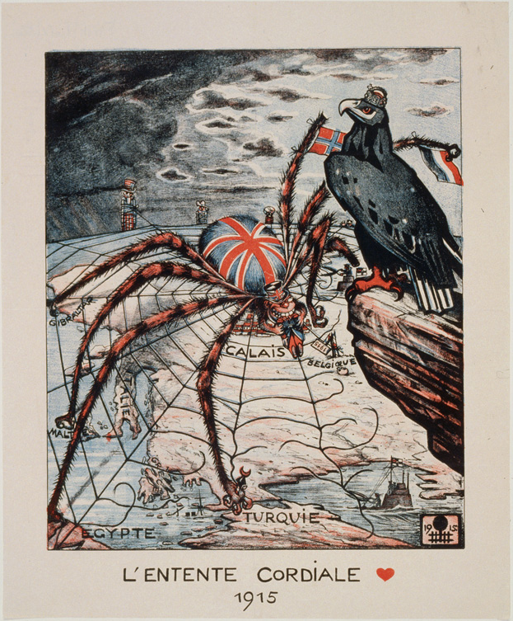
What does this German poster accuse the British of?

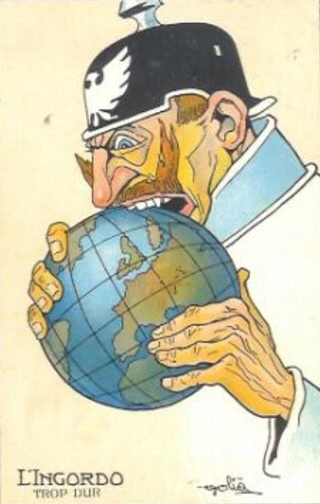
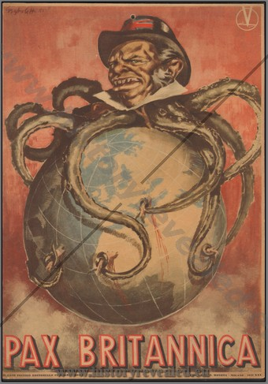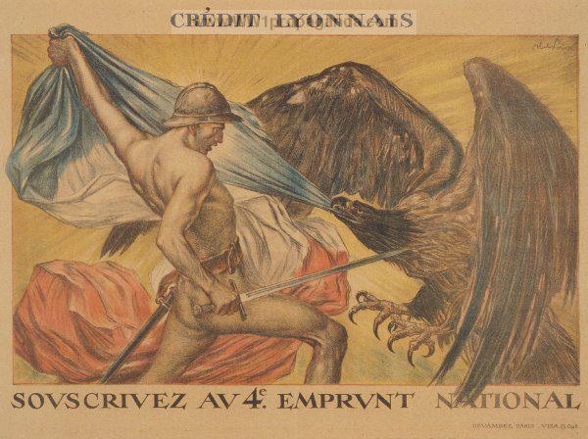
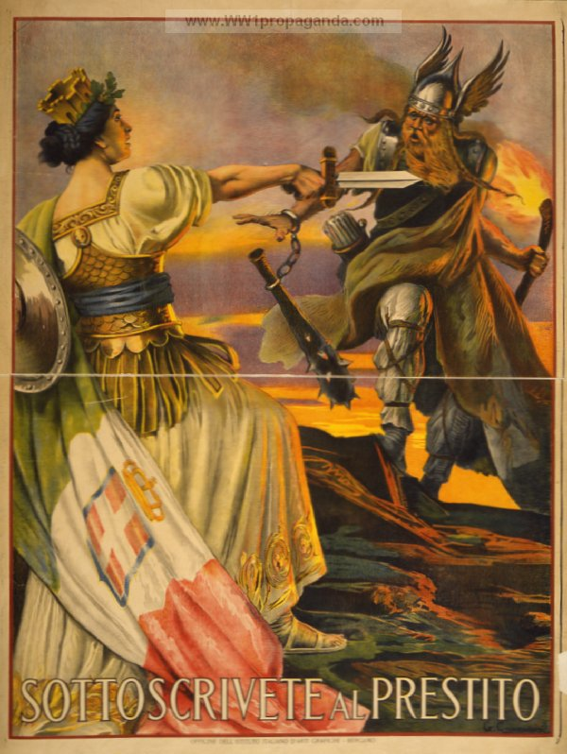
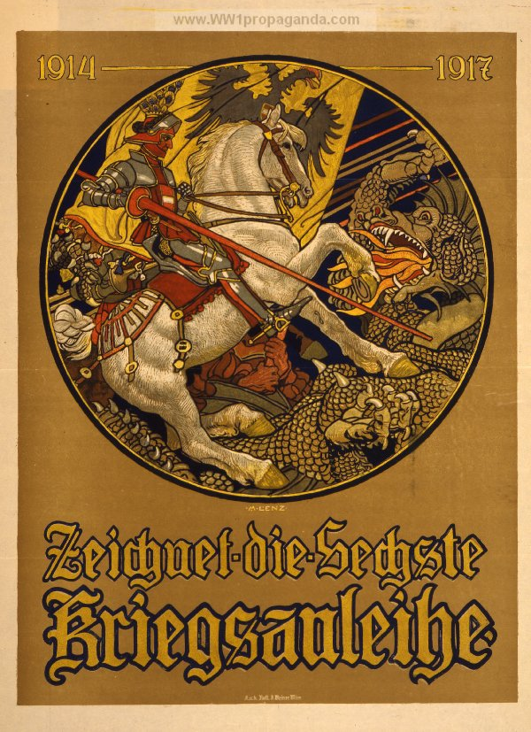
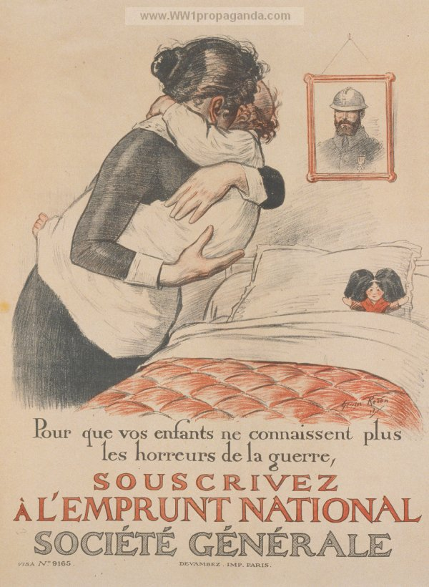
So that your children no longer know the horrors of war, subscribe to the National Loan.
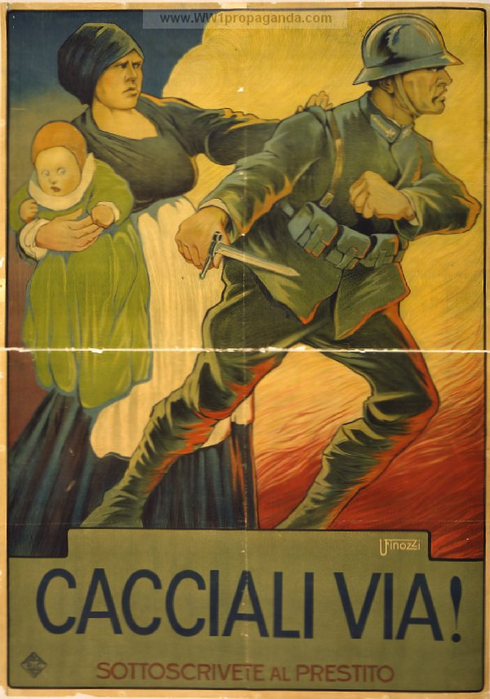
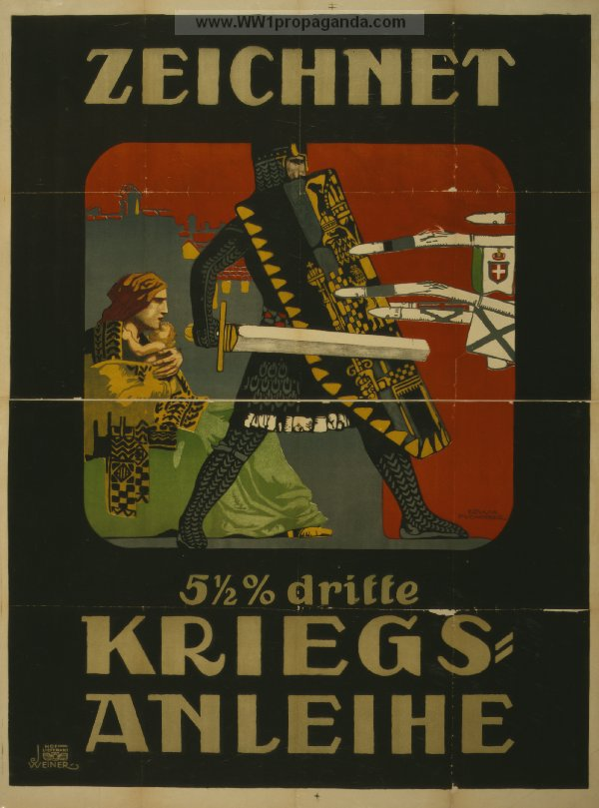
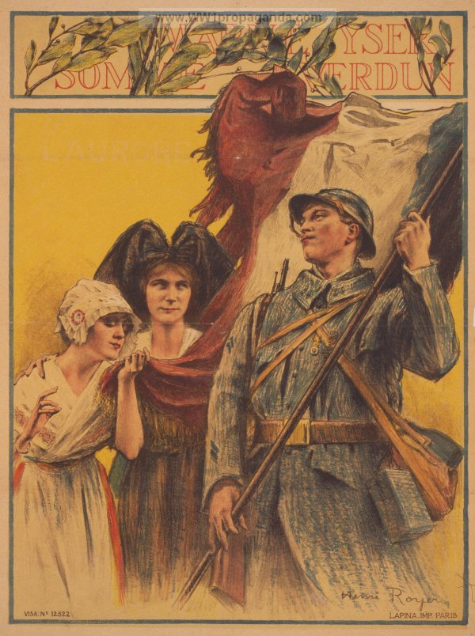
Subscribe to the Loan of the Liberation.
