“White Man’s Burden”
Some westerners felt that it was their responsibility to help “civilize” the “savage” inhabitants of colonial lands in order to make them more “modern” and European. The English writer Rudyard Kipling, for example, displayed such an attitude in his 1899 poem entitled “The White Man’s Burden,” the first stanza of which is printed to the right.
Take up the White Man’s Burden—
Send forth the best ye breed—
Go bind your sons in exile
To serve your captives’ need;
To wait in heavy harness
On fluttered folk and wild—
Your new-caught, sullen peoples
Half-devil and half-child.

- Which line in the poem describes non-white people?
- Why do you think the author uses these words?
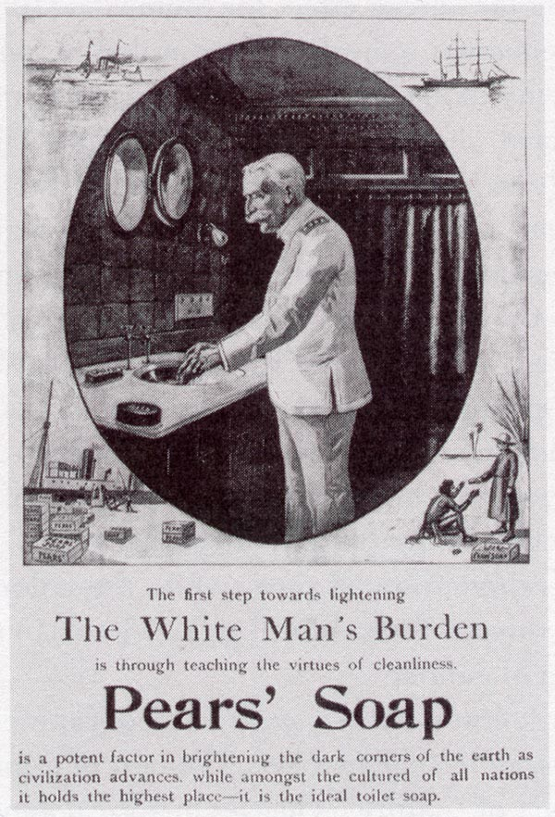
Before the advent of radio and television, companies relied heavily on posters like this to advertise their products. In this ad, the Pears’ Soap company equates the use of its product with fulfilling “The White Man’s Burden.”
The advertisement claims that
Pears’ soap is a potent factor in brightening the dark corners of the earth as civilization advances…
What do you think the phrase “dark corners of the earth” refers to? Why?
Imperialism in advertising—Pears’ Soap

Social Darwinism
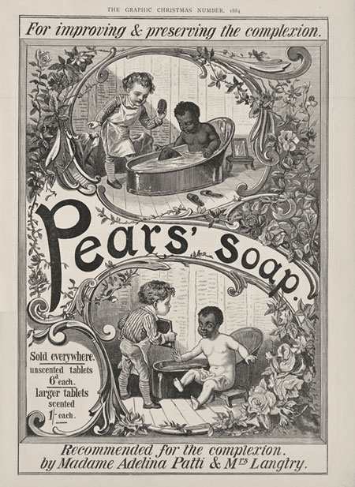
Some scholars applied Darwin’s theories of evolution—such as the notion of “survival of the fittest”—to human societies. According to the pseudo-science of Social Darwinism, Europe’s economic and political strength was proof of the superiority of the European “race.” This idea served as a justification for imperialism, as (white) Europeans claimed it was their mission to bring “civilization” to the “savage” people in their colonies, often in the form of new products and technology. Imperial images also played an important role in building national pride at home.
- What is the advertisement’s message?
- How does this advertisement for Pears’ Soap display Social Darwinist ideas?
- Would you be surprised to see this advertisement (or a similar one) in a store today? Why? Why not?
- Can you think of any commercials that are racially insensitive, or play on racial stereotypes?

Missionary Work
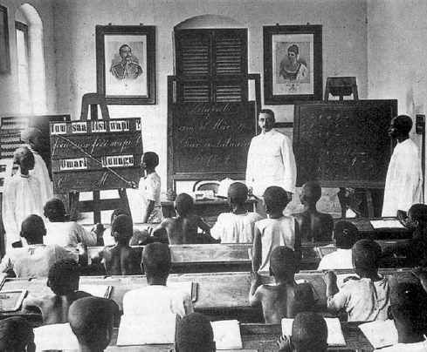
Many westerners, including doctors and some colonial officials, felt a genuine concern for improving the lives of the people living in colonial territories. European missionaries, for example, traveled to Africa in the hopes of spreading Christian beliefs and values. To the right is a picture of a missionary school in German-controlled East Africa, just before World War I.
- What kinds of things do you think are taught in this school? Why?
- What two figures’ portraits are hanging on the back wall? Why?

“White Man’s Burden”
Some westerners felt that it was their responsibility to help “civilize” the “savage” inhabitants of colonial lands in order to make them more “modern” and European. The English writer Rudyard Kipling, for example, displayed such an attitude in his 1899 poem entitled “The White Man’s Burden,” the first stanza of which is printed to the right.
Take up the White Man’s Burden—
Send forth the best ye breed—
Go bind your sons in exile
To serve your captives’ need;
To wait in heavy harness
On fluttered folk and wild—
Your new-caught, sullen peoples
Half-devil and half-child.

- Which line in the poem describes non-white people?
Several lines speak about people of color in a derogatory way: “wild”, “sullen”, “half-devil and half-child”
- Why do you think the author uses these words?
Kipling (also known for writing the Jungle Book) depicts Africans and Asians as uncivilized by describing them as sad and immature, as untamed and needing to be controlled. The “burden” of the white man is therefore to tame and civilize the “savage” peoples of the world.
Before the advent of radio and television, companies relied heavily on posters like this to advertise their products. In this ad, the Pears’ Soap company equates the use of its product with fulfilling “The White Man’s Burden.”
The advertisement claims that
Pears’ soap is a potent factor in brightening the dark corners of the earth as civilization advances…
- What do you think the phrase “dark corners of the earth” refers to? Why?
The “dark corners of the earth” likely refers to the non-European, non-white places, particularly Africa and Asia. The advertisement implies that those “dark corners” are unclean and uncivilized and that their soap is one way of bringing cleanliness and civilization to foreign lands.
Imperialism in advertising—Pears’ Soap

Social Darwinism
Some scholars applied Darwin’s theories of evolution—such as the notion of “survival of the fittest”—to human societies. According to the pseudo-science of Social Darwinism, Europe’s economic and political strength was proof of the superiority of the European “race.” This idea served as a justification for imperialism, as (white) Europeans claimed it was their mission to bring “civilization” to the “savage” people in their colonies, often in the form of new products and technology. Imperial images also played an important role in building national pride at home.
- What is the advertisement’s message?
The advertisement seems to be saying that Africans should become white. “Whiteness” is associated with cleanliness and improvement.
- How does this advertisement for Pears’ Soap display Social Darwinist ideas?
Social Darwinism takes Darwin’s ideas of natural selection and evolution and inappropriately puts them in a social context. It suggests that Europeans are more “evolved” and superior to other “races”. (As we have studied beforehand, there is not any genetic substance to racial thinking. It is purely a social category.) The advertisement suggests that Africans need to be made more European.
- Would you be surprised to see this advertisement (or a similar one) in a store today? Why? Why not?
- Can you think of any commercials that are racially insensitive, or play on racial stereotypes?

Missionary Work
Many westerners, including doctors and some colonial officials, felt a genuine concern for improving the lives of the people living in colonial territories. European missionaries, for example, traveled to Africa in the hopes of spreading Christian beliefs and values. To the right is a picture of a missionary school in German-controlled East Africa, just before World War I.
- What kinds of things do you think are taught in this school? Why?
The students are being taught German. It is wiping away their language and culture and imposing a German one on top
- What two figures’ portraits are hanging on the back wall? Why?
The portraits are of the German leader and his wife in order to show whose authority they should respect.

