The Three Estates

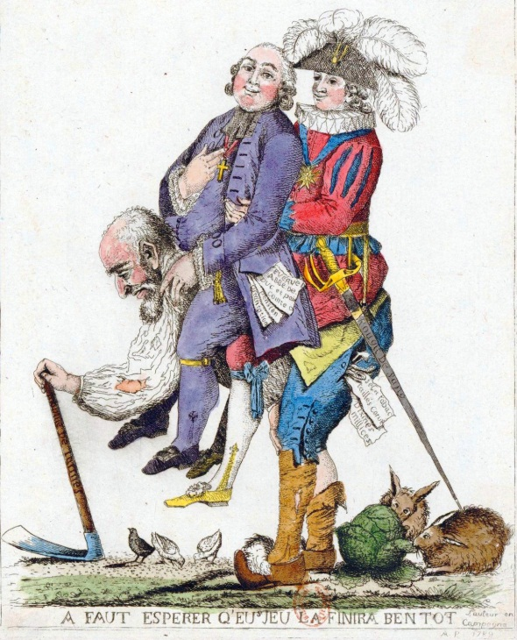
- Description: What details do you see?

- Reflection: What emotions or interpretations do you think about that?

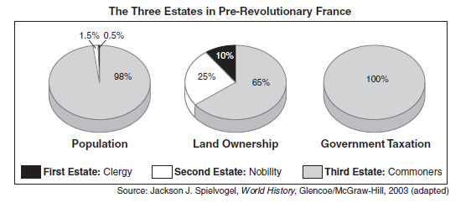
Early modern French society was legally stratified by birth. Its three traditional divisions, or "orders," were the clergy, the nobility, and the common people. Nobles ruled over commoners, but even among commoners, specific individuals (such as officeholders) or groups (such as a particular guild or an entire town) enjoyed privileges unavailable to outsiders. Because these privileges were passed on primarily through inheritance, they tended to constrain social mobility… Even as these privileges maintained a close grip on eighteenth-century imaginations, writers of the Enlightenment found them too rooted in tradition and proposed that talent supersede birth as the main determinant of social standing.
When the King called for an Estates-General in 1789, the social tensions plaguing the old regime emerged as a central issue of the Revolution. Traditionally, estates representatives had belonged to one of the three orders of society, and in principle each order had an equal voice before the King. Because nobles dominated the clergy, however, the majority of representatives actually came from the two privileged orders, even though they stood for only 5 percent of the population at most. Because each voter actually would exercise one vote in the assembly, this configuration allowed the nobility two of the three votes. The King subsequently agreed to double the size of the delegation of the Third Estate, but this move failed to appease critics of the political system. Many pamphlets appeared suggesting that representatives should vote by "head" rather than by "order" (meaning all representatives should vote together as a single assembly, rather than as three separate bodies representing three separate orders).
The purpose of such pamphlets was not merely to win greater representation for the Third Estate. Their authors were making the case for a new concept of society, in which commoners, especially the educated middle classes, had the same value as the other orders.
http://chnm.gmu.edu/revolution/

- Analysis: Given the background provided, how would you describe the meaning of the details you noticed and your prior response to the image?

