The Rhodes Colossus
The cartoon below shows Cecil John Rhodes (5 July 1853 – 26 March 1902), who was an English-born South African businessman, mining magnate, and politician. He was the founder of the diamond company De Beers, which today markets 40% of the world's rough diamonds and at one time marketed 90%. An ardent believer in British colonialism, he was the founder of the state of Rhodesia, which was named after him. In 1964, Northern Rhodesia became the independent state of Zambia and Southern Rhodesia was thereafter known simply as Rhodesia. In 1980, Rhodesia, which had been de-facto independent since 1965, became independent from Britain and was renamed Zimbabwe
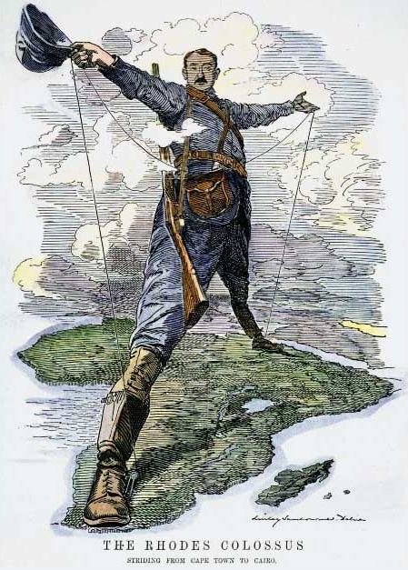
Use the picture to answer the following questions:
- Description: What details do you see?
- Reflection: What do you think?
A. What emotions does the image prompt? How do you interpret the image?
B. What do you wonder? What questions do you have?

- Analysis:
This satirical image of an immense Cecil Rhodes, arms outstretched, astride the entire continent of Africa is "one of the most familiar of all 19th Century political cartoons . . . the 'archetypal image of British imperial power.'" (Scully 2012, 120). By 1892, Rhodes' commercial and business interests in South Africa had merged with his "message of imperial patriotism" as the Premier [leader] of the Cape Colony (Ibid. 125). On November 29, 1892, while on a visit to London, Rhodes made a speech in which he dramatically announced that he intended to extend the Colony's telegraphic connections across the entire continent - not only to Lake Tanganyika and Uganda, but through the Islamic Sudan and all the way to British Cairo. The speech was reported in the Times, and promptly became of interest to the editors of Punch. The magazine had often used references to the ancient Greek Colossus of Rhodes, and the pun here had "sheer familiarity and obviousness." (Ibid. 128).
A. After reading about the background, describe the meaning of the details you noted beforehand and expand upon your reflection?
Rhodes once said in 1891
I contend that we are the first race in the world, and that the more of the world that we inhabit the better it is for the human race.
I contend that every acre added to our territory means the birth of more of the English race who otherwise would not be brought into existence...
B. What do you think he meant by this?
C. Why he is in Africa (political)? Why he is taking land (economic)? How does he justify his actions (social)?

Scramble for Africa
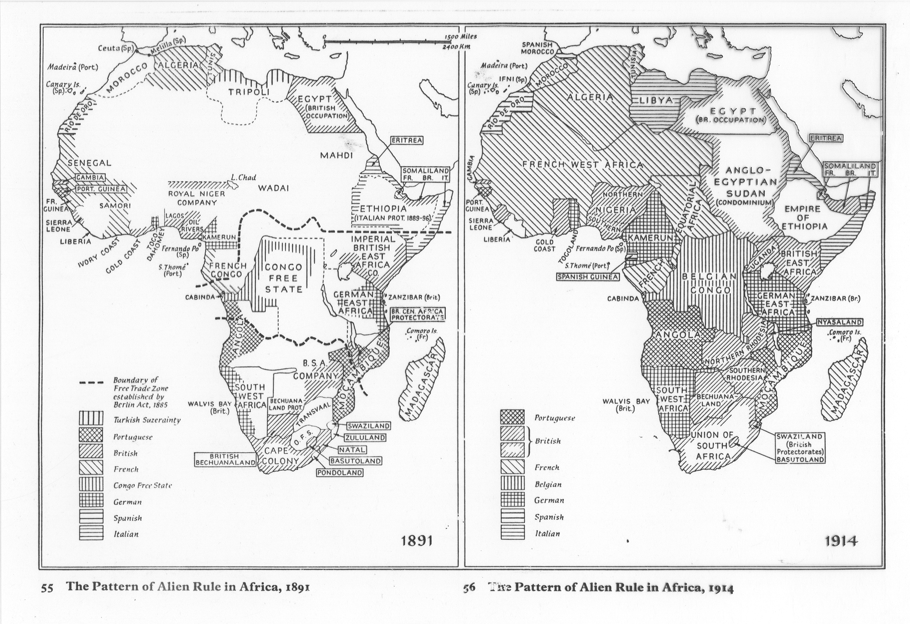

The Industrial Revolution helped many western nations achieve unmatched economic and political power. In 1884, leaders of the European powers held an international conference in Berlin to discuss the partition of Africa. Without much knowledge of or regard for traditional African ethnic communities and territorial boundaries, Europeans drew their own borders and agreed to recognize the colonial acquisitions of any other European power. Within just 30 years, almost all of Africa—a continent four times as large as Europe—was under European political control.
MAP ACTIVITY
You will need different colored pens or magic markers for this exercise.
- Look at the map of Africa on the previous page (from 1914). Which countries held colonies in Africa?
- Using a different color for each of the European nations you listed in Question #1, color in that nation’s colonial territories.
- Which two countries held the most land in Africa?
- According to this map, how many African nations managed to resist colonization (as of 1914)?

The Rhodes Colossus
The cartoon below shows Cecil John Rhodes (5 July 1853 – 26 March 1902), who was an English-born South African businessman, mining magnate, and politician. He was the founder of the diamond company De Beers, which today markets 40% of the world's rough diamonds and at one time marketed 90%. An ardent believer in British colonialism, he was the founder of the state of Rhodesia, which was named after him. In 1964, Northern Rhodesia became the independent state of Zambia and Southern Rhodesia was thereafter known simply as Rhodesia. In 1980, Rhodesia, which had been de-facto independent since 1965, became independent from Britain and was renamed Zimbabwe
Use the picture to answer the following questions:
- Description: What details do you see?
- Reflection: What do you think?
A. What emotions does the image prompt? How do you interpret the image?
B. What do you wonder? What questions do you have?

- Analysis:
This satirical image of an immense Cecil Rhodes, arms outstretched, astride the entire continent of Africa is "one of the most familiar of all 19th Century political cartoons . . . the 'archetypal image of British imperial power.'" (Scully 2012, 120). By 1892, Rhodes' commercial and business interests in South Africa had merged with his "message of imperial patriotism" as the Premier [leader] of the Cape Colony (Ibid. 125). On November 29, 1892, while on a visit to London, Rhodes made a speech in which he dramatically announced that he intended to extend the Colony's telegraphic connections across the entire continent - not only to Lake Tanganyika and Uganda, but through the Islamic Sudan and all the way to British Cairo. The speech was reported in the Times, and promptly became of interest to the editors of Punch. The magazine had often used references to the ancient Greek Colossus of Rhodes, and the pun here had "sheer familiarity and obviousness." (Ibid. 128).
A. After reading about the background, describe the meaning of the details you noted beforehand and expand upon your reflection?
Cecil Rhodes is standing over Africa holding a telegraph wire, dressed as an adventurer. This represents his desire to connect the British colonies at the northern and southern ends of Africa by conquering the lands in between. The telegraph often went hand in hand with railroad lines, which also supported the expansion of political and economic control of areas. The image also plays on the wonder of the ancient world where an enormous statue provided an entrance to the Greek city of Rhodes. Here the cartoonist plays on the name of the city and Cecil’s last name to create the political cartoon.
Rhodes once said in 1891
I contend that we are the first race in the world, and that the more of the world that we inhabit the better it is for the human race.
I contend that every acre added to our territory means the birth of more of the English race who otherwise would not be brought into existence...
B. What do you think he meant by this?
Cecil Rhodes believes that the British are a superior part of the human race. As such, the British should conquer other lands in order to civilize them. The more of British culture the world learns the better the world will be.
C. Why he is in Africa (political)? Why he is taking land (economic)? How does he justify his actions (social)?
Cecil Rhodes is in Africa to gain control of Africa and its resources. The industrial revolution is driving Europeans outward in the pursuit of natural resources. Industrialization creates an appetite for natural resources to fill its factories. Factories are increasing in production and that creates a demand for more natural resources. Europeans disguise these real motives under the veneer of civilizing other nations.

Scramble for Africa

The Industrial Revolution helped many western nations achieve unmatched economic and political power. In 1884, leaders of the European powers held an international conference in Berlin to discuss the partition of Africa. Without much knowledge of or regard for traditional African ethnic communities and territorial boundaries, Europeans drew their own borders and agreed to recognize the colonial acquisitions of any other European power. Within just 30 years, almost all of Africa—a continent four times as large as Europe—was under European political control.
MAP ACTIVITY
You will need different colored pens or magic markers for this exercise.
- Look at the map of Africa on the previous page (from 1914). Which countries held colonies in Africa?
Portugal, Britain, France, Belgium, Germany, Spain, and Italy
- Using a different color for each of the European nations you listed in Question #1, color in that nation’s colonial territories.
- Which two countries held the most land in Africa?
France and Britain
- According to this map, how many African nations managed to resist colonization (as of 1914)?
Ethiopia and Liberia

