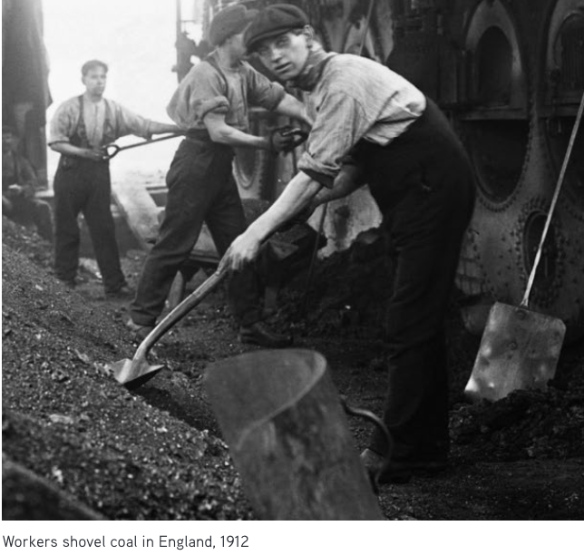
The transformation of the world

At one time, humans provided most of their own energy. They ate plants and animals for fuel, burned wood, and were helped by domestic animals. Windmills and waterwheels captured some extra energy, but little could be saved. All life depended on the energy the Sun sent to the Earth.
Everything changed during the Industrial Revolution, which began around 1750. People found an extra source of energy that could work for them. That source was fossil fuels — coal, oil, and natural gas. These formed underground from the remains of plants and animals from much earlier geologic times. When they were burned, they released energy, originally from the Sun, that had been stored for hundreds of millions of years.
Coal was formed when huge trees from the Carboniferous period (345 million to 280 million years ago) fell and were covered with water, so that oxygen and bacteria could not decay them. Materials pushing down compressed them into dark, carbonic, burnable rock.
Most of the Earth’s oil and gas formed over a hundred million years ago from tiny animal skeletons and plant matter that fell to the bottom of seas or were buried in sediment. This organic matter was compressed by the weight of water and soil.
Coal, oil, and gas are relatively common on Earth. But they are not evenly distributed. Some places have much more than others due to the diverse ecosystems that existed long ago.

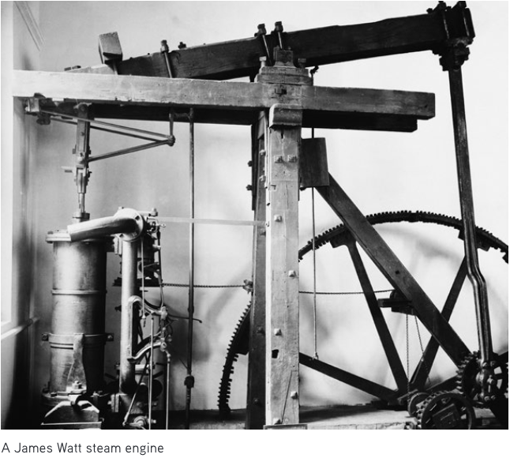
Early steam engines

The story of the Industrial Revolution begins on the small island of Great Britain. By the early eighteenth century, people there had cut down most of their trees to build houses or ships and for cooking and heating. They needed something else to burn. They turned to the hunks of black stone (coal) that they found near the surface of the Earth. Soon they were digging deeper to mine it. These coal mines, deep in the Earth, began to fill with water. Using horses to pull up bucketfuls of water was too slow.
To the rescue came James Watt (1736–1819), a Scottish instrument-maker. In 1776, he designed an engine that used burning coal to produce steam. The steam drove a piston. This steam engine was first used to efficiently pump water out of coal mines. But his engine worked well, and it was put to other uses. He became a wealthy man. After his patent ran out in 1800, others improved on his engine. By 1900, engines burned 10 times more efficiently than they had a hundred years before.

Parts, Purposes, and Puzzles

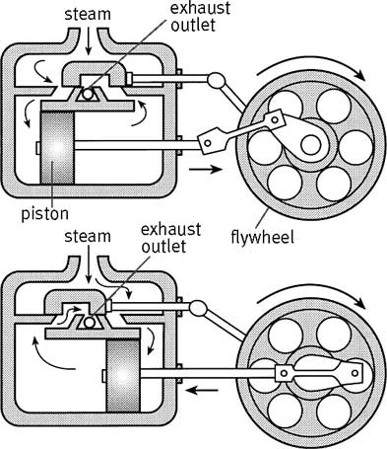

What are the parts of the steam engine? | What is their purpose?
Steam inlet/outlet

valve

Cylinder

Piston

Piston rod

Flywheel

What puzzles remain?
What material should it be made from?

What source of energy will boil water for steam?

What was the benefit of the steam engine?

What uses can the steam engine be put toward?

Parts, Purposes, and Puzzles

What are the parts of the steam engine? | What is their purpose?
Steam inlet/outlet | The inlet/outlet allows the steam to enter and exit the cylinder
valve | The valve controls which side of the cylinder the steam will enter.
Cylinder | The cylinder captures the pressure of the steam to direct the piston.
Piston | The piston is the moving part of the engine that receives the pressure of the steam
Piston rod | The piston rod directs the movement from inside the cylinder outside upon the wheel
Flywheel | The flywheel captures the inertia of the movement.

What puzzles remain?
What material should it be made from?
In order to capture the pressure of the steam, the engine must be made of a strong material, like metal.
What source of energy will boil water for steam?
Any combustible matter will work, but at the time people were transitioning from wood to fossil fuels, like coal and oil.
What was the benefit of the steam engine?
Previously wind and water were used to power machines, but those machines depended on the proper location. The steam engine could be used anywhere and was not dependent environmental factors.
What uses can the steam engine be put toward?
The movement can be put toward transportation by turning the wheels that move trains, steamboats and cars. They also can be used to power various types of machinery like pumps, looms, spinners.

