Comparison of Adam Smith and Karl Marx

Adam Smith | Karl Marx
- Division of Labor: productivity increases through specialization. | Alienation: specialization makes work tedious and meaningless. Workers no longer have a connection to labor as personal creation; there is a loss of self-worth.
- Supply and demand determine the price of products and services. 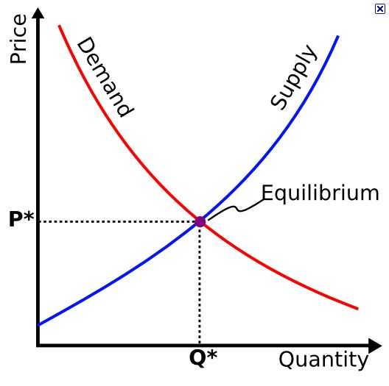 | The amount of labor that went into production should be equated into the price, but capitalists exploit labor and enrich themselves by extracting “surplus-value”—profit.
- The invisible hand: The economy will regulate itself through expanding markets so that the self-interest of the producer will match the self-interest of the producer. | Instability: the market is inherently unstable because it can never achieve equilibrium. There will always be market fluctuations with booms and busts.
- Wealth: accumulation of wealth through production (rather than gold) and reinvestment. | Exploitation: the bourgeois (capitalist) accumulation of wealth will be at the expense of the proletariat (worker). The surplus of labor threatens job security and forces workers into unfitting and unfair working conditions in the pursuit of profit  Likewise the consumer is conformed through advertising to focus on the product—commodity fetishism—while blind to the process of production which impact people and the planet.

3 P’s
Profit
People
Planet

