Revolution Begins
Louis XVI called a meeting of the Estates-General at Versailles on May 5, 1789. In the Estates-General, the First and Second Estates each had about 300 representatives. The Third Estate had almost 600 representatives. Most of the Third Estate wanted to set up a constitutional government that would make the clergy and nobility pay taxes, too.
From the start, there were arguments about voting. Traditionally, each estate had one vote—the First and Second Estates could outvote the Third Estate two to one. The Third Estate demanded instead that each deputy have one vote. Under this new system, with the help of a few nobles and clerics, the Third Estate would then have the majority vote. The king stated that he favored the current system.
On June 17, 1789, the Third Estate boldly declared that it was the National Assembly and would draft a constitution. Three days later, on June 20, its deputies arrived at their meeting place, only to find the doors had been locked. They then moved to a nearby indoor tennis court and swore that they would continue meeting until they had a new constitution. The oath they swore is known as the Tennis Court Oath.
Louis XVI prepared to use force against the Third Estate. On July 14, 1789, about 900 Parisians gathered in the courtyard of the Bastille—an old fortress, used as a prison and armory. The price of bread had reached record highs so the crowd was hungry and agitated. According to rumor, the king’s troops were coming, and there was ammunition in the Bastille. A group of attackers managed to lower the two drawbridges over the moat. Members of the French Guard joined the attack. After four hours of fighting, the prison warden surrendered. The rebels released the seven prisoners and cut off the prison warden’s head. Angered there were no munitions, the crowd demolished the Bastille brick by brick. Paris was abandoned to the rebels.
When King Louis XVI returned to his place at Versailles after a day of hunting, the duc de la Rochefoucauld-Liancourt told him about the fall of the Bastille. Louis is said to have exclaimed, “Why, this a revolt.” “No, Sire,” replied the duke. “It is a revolution.”
Louis XVI was informed that he could no longer trust royal troops to shoot at the mob. The king’s authority had collapsed in Paris. Meanwhile, all over France, revolts were breaking out. Popular hatred of the entire landholding system, with its fees and obligations, had finally spilled over into action
Peasant rebellions became part of the vast panic known as the Great Fear. The peasants feared that the work of the National Assembly would be stopped by foreign armies. Rumors spread from village to village that foreign troops were on the way to put down the revolution. The peasants reacted by breaking into the houses of the lords to destroy the records of their obligations.
Glencoe World History 2008

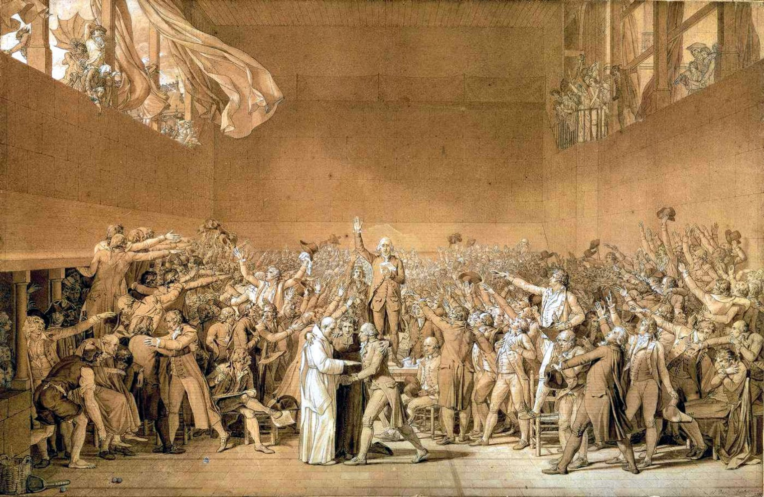
Jacques-Louis David, Tennis Court Oath
- How is the assembly depicted in this drawing connected to the doctrine of divine right?
- How is the assembly depicted in this drawing connected to the Seven Years War?

