JEWISH RESISTANCE
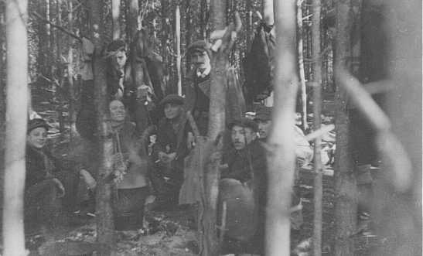
Nazi-sponsored persecution and mass murder fueled resistance to the Germans in the Third Reich itself and throughout occupied Europe. Although Jews were the Nazis' primary victims, they too resisted Nazi oppression in a variety of ways, both collectively and as individuals.
Jewish partisans, survivors of the Warsaw ghetto uprising, at a family camp in Wyszkow forest. Poland, 1944.
— YIVO Institute for Jewish Research, New York
Organized armed resistance was the most forceful form of Jewish opposition to Nazi policies in German-occupied Europe. Jewish civilians offered armed resistance in over 100 ghettos in occupied Poland and the Soviet Union. In April-May 1943, Jews in the Warsaw ghetto rose in armed revolt after rumors that the Germans would deport the remaining ghetto inhabitants to the Treblinka killing center. As German SS and police units entered the ghetto, members of the Jewish Fighting Organization (Zydowska Organizacja Bojowa; ZOB) and other Jewish groups attacked German tanks with Molotov cocktails, hand grenades, and a handful of small arms. Although the Germans, shocked by the ferocity of resistance, were able to end the major fighting within a few days, it took the vastly superior German forces nearly a month before they were able to completely pacify the ghetto and deport virtually all of the remaining inhabitants. For months after the end of the Warsaw ghetto uprising, individual Jewish resisters continued to hide in the ruins of the ghetto, which SS and police units patrolled to prevent attacks on German personnel.
During the same year, ghetto inhabitants rose against the Germans in Vilna (Vilnius), Bialystok, and a number of other ghettos. Many ghetto fighters took up arms in the knowledge that the majority of ghetto inhabitants had already been deported to the killing centers; and also in the knowledge that their resistance even now could not save from destruction the remaining Jews who could not fight. But they fought for the sake of Jewish honor and to avenge the slaughter of so many Jews.
Thousands of young Jews resisted by escaping from the ghettos into the forests. There they joined Soviet partisan units or formed separate partisan units to harass the German occupiers. Although many Jewish council (Judenrat) members cooperated under compulsion with the Germans until they themselves were deported, some, such as Jewish council chairman Moshe Jaffe in Minsk, resisted by refusing to comply when the Germans ordered him to hand over Jews for deportation in July 1942.
Jewish prisoners rose against their guards at three killing centers. At Treblinka in August 1943 and Sobibor in October 1943, prisoners armed with stolen weapons attacked the SS staff and the Trawniki-trained auxiliary guards. The Germans and their auxiliaries killed most of the rebels, either during the uprising or later, after hunting down those who escaped. Several dozen prisoners eluded their pursuers and survived the war, however. In October 1944, at Auschwitz-Birkenau, members of the Jewish Special Detachment (Sonderkommando) mutinied against the SS guards. Nearly 250 died during the fighting; the SS guards shot another 200 after the mutiny was suppressed. Several days later, the SS identified five women, four of them Jewish, who had been involved in supplying the members of the Sonderkommando with explosives to blow up a crematorium. All five women were killed.
In many countries occupied by or allied with the Germans, Jewish resistance often took the form of aid and rescue. Jewish authorities in Palestine sent clandestine parachutists such as Hannah Szenes into Hungary and Slovakia in 1944 to give whatever help they could to Jews in hiding. In France, various elements of the Jewish underground consolidated to form different resistance groups, including the Armée Juive (Jewish Army) which operated in the south of France. Many Jews fought as members of national resistance movements in Belgium, France, Italy, Poland, Yugoslavia, Greece, and Slovakia.
Jews in the ghettos and camps also responded to Nazi oppression with various forms of spiritual resistance. They made conscious attempts to preserve the history and communal life of the Jewish people despite Nazi efforts to eradicate the Jews from human memory. These efforts included: creating Jewish cultural institutions, continuing to observe religious holidays and rituals, providing clandestine education, publishing underground newspapers, and collecting and hiding documentation, as in the case of the Oneg Shabbat archive in Warsaw that would tell the story of the Jews in the Warsaw ghetto, despite its destruction in 1943.

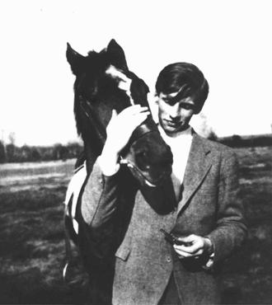
WHITE ROSE
Figure 1Alexander Schmorell, a member of the White Rose student opposition, upon his graduation from high school. Schmorell was arrested, condemned to death by the People's Court, and executed on July 13, 1943. –Bildarchiv Preussischer Kulturbesitz

In 1942 Hans Scholl, a medical student at the University of Munich, his sister Sophie, Christoph Probst, Willi Graf, and Alexander Schmorell founded the “White Rose” movement, one of the few German groups that spoke out against Nazi genocidal policies.
Nazi tyranny and the apathy of German citizens in the face of the regime’s “abominable crimes” outraged idealistic “White Rose” members. Many of them had heard about the mass murder of Polish Jews; as a soldier on the eastern front, Hans Scholl had also seen firsthand the mistreatment of Jewish forced laborers and heard of the deportation of large numbers of Poles to concentration camps.
The group expanded into an organization of students in Hamburg, Freiburg, Berlin, and Vienna. At great risk, “White Rose” members transported and mailed mimeographed leaflets that denounced the regime. In their attempt to stop the war effort, they advocated the sabotage of the armaments industry. “We will not be silent,” they wrote to their fellow students. “We are your bad conscience. The White Rose will not leave you in peace!" Because the students were aware that only military force could end Nazi domination, they limited their aims to achieve “a renewal from within of the severely wounded German spirit.”
After the German army’s defeat at Stalingrad in late January 1943, the Scholls distributed pamphlets urging students in Munich to rebel. But in the next month, a university janitor who saw them with the pamphlets betrayed them to the Gestapo (German secret state police).
The regime executed Hans and Sophie Scholl and Christoph Probst on February 22, 1943. Officials also eventually arrested and executed philosophy professor Kurt Huber, who had guided the movement, and the rest of the “White Rose” members.
At his trial Huber remained loyal to the eighteenth century German philosopher Immanuel Kant’s ethical teaching, as he concluded his defense with the words of Kant’s disciple Johann Gottlieb Fichte:
And thou shalt act as if
On thee and on thy deed
Depended the fate of all Germany,
And thou alone must answer for it.

RESCUE IN DENMARK
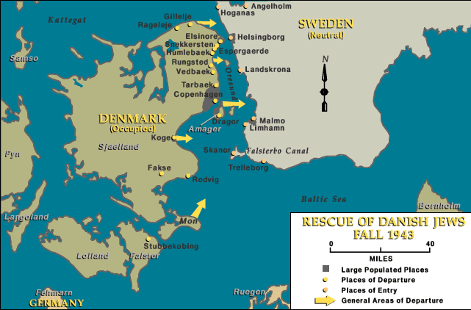
Most individuals in occupied Europe did not actively collaborate in the Nazi genocide. Nor did they do anything to help Jews and other victims of Nazi policies. Throughout the Holocaust, millions of people silently stood by while they saw Jews, Roma (Gypsies), and other "enemies of the Reich" being rounded up and deported. Many of these bystanders told themselves that what they saw happening was none of their business. Others were too frightened to help. In many places, providing shelter to Jews was a crime punishable by death.
In spite of the risks, a small number of individuals refused to stand by and watch.These people had the courage to help by providing hiding places, underground escape routes, false papers, food, clothing, money, and sometimes even weapons.
Denmark was the only occupied country that actively resisted the Nazi regime's attempts to deport its Jewish citizens. On September 28, 1943, Georg Ferdinand Duckwitz, a German diplomat, secretly informed the Danish resistance that the Nazis were planning to deport the Danish Jews. The Danes responded quickly, organizing a nationwide effort to smuggle the Jews by sea to neutral Sweden. Warned of the German plans, Jews began to leave Copenhagen, where most of the almost 8,000 Jews in Denmark lived, and other cities, by train, car, and on foot. With the help of the Danish people, they found hiding places in homes, hospitals, and churches. Within a two-week period fishermen helped ferry some 7,200 Danish Jews and 680 non-Jewish family members to safety across the narrow body of water separating Denmark from Sweden.
The Danish rescue effort was unique because it was nationwide. It was not completely successful, however. Almost 500 Danish Jews were deported to the Theresienstadt ghetto in Czechoslovakia. Yet even of these Jews, all but 51 survived the Holocaust, largely because Danish officials pressured the Germans with their concerns for the well-being of those who had been deported. The Danes proved that widespread support for Jews and resistance to Nazi policies could save lives.
There are numerous stories of brave people in other countries who also tried to save the Jews from perishing at the hands of the Nazis. Nearly 12,000 Jewish children were rescued by clergymen in France who found housing for them and even smuggled some into Switzerland and Spain. About 20,000 Polish Jews were able to survive in hiding outside the ghetto in Warsaw because people provided shelter for them in their homes. Some Jews were even hidden in the Warsaw Zoo by the zoo's director, Jan Zabinski.

OBSTACLES TO IMMIGRATION
EMIGRATION FROM GERMANY
From 1933 until October 23, 1941, Nazi Germany pursued a policy of forced Jewish emigration. Antisemitic legislation and terror served to "encourage" and ultimately to compel hundreds of thousands of German Jews to leave.The government did all it could to make the Jews emigrate. In addition to making life miserable, the German authorities reduced bureaucratic hurdles so those who wanted to leave could do so more easily.
At the same time, the Nazis viewed the Jews' belongings and their financial capital as German property, and they had no intention of allowing refugees to take anything of material value with them. Most of those who fled had to relinquish their titles to homes and businesses, and were subject to increasingly heavy emigration taxes that reduced their assets. Furthermore, the German authorities restricted how much money could be transferred abroad from German banks, and allowed each passenger to take only ten reichsmarks (about US $4) out of the country. Most of the German Jews who managed to emigrate were completely impoverished by the time they were able to leave.
OBSTACLES TO IMMIGRATION
Many nations in which the German Jews sought asylum imposed significant obstacles to immigration. Application processes for entry visas were elaborate and demanding, requiring prospective immigrants to provide information about themselves and their family members from banks, doctors, and the German police. In the case of the United States, applicants were required to provide affidavits from multiple sponsors and to have secured a waiting number within a quota established for their country of birth, which severely limited their chances to emigrate.
All this red tape existed against the backdrop of other hardships: competition with thousands of equally desperate people, slow mail that made communication with would-be sponsors difficult, financial hardships, and oppressive measures in Germany that made even the simplest task a chore. Finally, many who wanted to flee had, by necessity, to apply to numerous countries for entry. It is no wonder that for many Jews in Germany in the 1930s, the attempt to emigrate was more than a full-time job.

THE 1930s
In the late 1930s, a severe worldwide economic depression reinforced through Europe and the United States an existing fear and mistrust of foreigners in general, as well as antisemitism in particular. Above all, people were wary of immigrants who might compete for their jobs, burden their already beleaguered social services, or be tempted as impoverished workers by the promises of labor agitators or domestic Communist movements.
Even government officials in democratic countries were not immune to those sentiments. Most foreign countries, including the United States, Canada, and Great Britain, were unwilling to increase their immigrant quotas to admit very large groups of refugees, especially the impoverished and the dispossessed. Indeed, the United States refused to reduce the many obstacles to getting an immigrant visa, with the result that until 1938, the immigration quota for Germany was unfilled. Many German Jews who were in immediate danger were forced to emigrate elsewhere, such as France, the Netherlands, and Czechoslovakia, where eventually the wave of German conquest overtook them.
The bureaucratic hurdles for emigration were overwhelming. Far from streamlining the process to allow more refugees to enter, nations required extensive documentation that was often virtually impossible to obtain. In some cases, refugees literally faced a "catch-22": proof of passage booked on a ship was required for a visa, and proof of a visa was required to book passage on a ship.
EVIAN CONFERENCE
After Germany annexed Austria in March 1938 and Nazi-sponsored street violence in both Austria and Germany dramatically increased the numbers of German and Austrian Jews seeking to emigrate, pressure mounted on US President Franklin D. Roosevelt to address the intensified refugee crisis. He responded by proposing an international conference to be held in the French resort town of Evian-les-Bains on July 6–15, 1938.
At the same time, the tone of the invitation reflected US and international ambivalence about the refugee situation. Thirty-three nations were invited with the reassurance that "no country will be expected... to receive a greater number of immigrants than is permitted by existing legislation."

DIETRICH BONHOEFFER
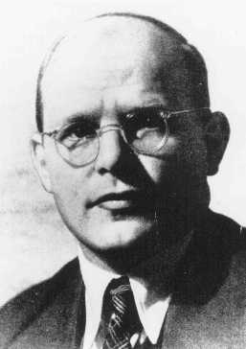
Protestant theologian Dietrich Bonhoeffer stands out among the Christian leaders during the Nazi era, for he was one of the few to actively resist the racist actions of the Nazi regime. In addition to his legacy of courageous opposition to Nazism, Bonhoeffer's theological writings are still widely read in Christian communities throughout the world.

Education
Dietrich Bonhoeffer was the sixth child of Karl and Paula Bonhoeffer, born in Breslau, Germany, on February 4, 1906. He completed his studies in Tübingen and Berlin. In 1928, he served as vicar in the German parish in Barcelona; and in 1930, he completed his theological examinations at Union Seminary in New York. During this period, he became active in the ecumenical movement and accumulated international contacts that would later aid his efforts in the resistance. In 1931, Bonhoeffer took a teaching position with the theological faculty in Berlin.

Hitler Rises to Power
After years of political instability under the Weimar republic, most Christian institutions were relieved with the ascent of the nationalistic Nazi dictatorship. The German Evangelical Church, the foremost Protestant church in Germany, welcomed Hitler's government in 1933. Dietrich Bonhoeffer, however, although a member of the German Evangelical Church, was not complacent. In his April 1933 essay, The Church and the Jewish Question, he assailed Nazi state persecution.The Nazi injustice must not go unquestioned, and the victims of this injustice must not go unaided, regardless of their religion, Bonhoeffer wrote.
With Hitler's ascent, non-Aryans were prohibited from taking parish posts, and when Bonhoeffer was offered such a post in the fall of 1933, he refused it in protest of the racist policy. Disheartened by the German Church's complacency with the Nazi regime, he decided to accept a position at a German-speaking congregation in London.
The opponents of Nazi interference in Church affairs formed the "Confessing Church," and some members, including Bonhoeffer, advocated open resistance against Nazism. The more moderate Protestants made what they saw as necessary compromises to retain their clerical authority despite expanding Nazi control. But under increasing Gestapo scrutiny, the Confessing Church was soon immobilized.
Bonhoeffer returned to Germany to teach at Finkenwalde, a Confessing Church seminary, where he continued to train clergy for the Confessing Church. But the official church barred his students from taking its clerical posts. In August 1937, the regime announced the Himmler Decree, which declared the training and examination of Confessing ministry candidates illegal. Finkenwalde was closed in September 1937; some of Bonhoeffer's students were arrested.

Resistance
Bonhoeffer went into hiding for the next two years; he traveled secretly from one eastern German village to another to help his students in their small illegal parishes. In January 1938, he was banned from Berlin, and in September 1940, he was forbidden to speak in public.
In the midst of political turmoil, Bonhoeffer continued to question the proper role of a Christian in Nazi Germany. When German synagogues and Jewish businesses were burned and demolished on Kristallnacht, November 9, 1938, Bonhoeffer immediately left for Berlin, despite having been banned by the Gestapo, to investigate the destruction. After his return, when his students were discussing the theological significance of Kristallnacht, Bonhoeffer rejected the theory that Kristallnacht had resulted from "the curse which had haunted the Jews since Jesus' death on the cross." Instead, Bonhoeffer called the pogrom an example of the "sheer violence" of Nazism's "godless face."²
The Confessing Church resistance expanded its efforts to help "non-Aryan" refugees leave the country. One member of the resistance movement was the passionate anti-Nazi, Hans von Dohnanyi, a lawyer married to Bonhoeffer's sister. In early 1939, Dohnanyi was transferred from the Justice Department to the Armed Forces High Command Office of Military Intelligence, and used his new post to inform Bonhoeffer that war was imminent. Bonhoeffer, knowing that he would never fight in Hitler's army, left the country in June 1939 for a teaching position at Union Seminary in New York.
But upon arrival in the United States, Bonhoeffer realized that he had been mistaken, that if he did not lead his people during the difficult years of war and turmoil, then he could not partake in the postwar revival of German Christan life. His place, he decided, was in Germany; he returned only a month after his departure, in July 1939. He undertook a more active effort to undermine the regime. With international contacts in the ecumenical movement, he became a crucial leader in the German underground movement.
In October 1940, despite previous Gestapo tracking, Bonhoeffer gained employment as an agent for Hans von Dohnanyi's Office of Military Intelligence, supposedly working for the expansion of Nazism. In reality, he worked for the expansion of the anti-Nazi resistance. During his 1941 and 1942 visits to Italy, Switzerland, and the Scandinavian countries, he attempted to gain foreign support for the resistance movement.

Arrest
While plans to topple Hitler progressed only slowly, the need to evacuate more Jewish refugees became increasingly urgent. In early 1943, however, the Gestapo, which had traced Bonhoeffer and Dohnanyi's large monetary sums intended for Jewish immigrants, foiled plans for a new refugee rescue mission. Bonhoeffer and Dohnanyi were arrested in April 1943.
Initially, the Gestapo believed that Bonhoeffer and Dohnanyi were embezzling money for their own interests. Then the truth began to leak out, and Bonhoeffer was subsequently charged with conspiring to rescue Jews, using official travel for other interests, and abusing his intelligence position to keep Confessing Church pastors out of the military. But the extent of Bonhoeffer's resistance activities was not fully realized for months.
In October 1944, Bonhoeffer was moved to the Gestapo prison in Berlin. In February 1945, he was taken to the Buchenwald concentration camp, and then to the Flossenbürg concentration camp, where he was hanged on April 9, 1945. Hans von Dohnanyi was executed soonthereafter.

“We are not to simply bandage the wounds of victims beneath the wheels of injustice, we are to drive a spoke into the wheel itself.” Bonheoffer
First they came for the Socialists, and I did not speak out—
Because I was not a Socialist.
Then they came for the Trade Unionists, and I did not speak out—
Because I was not a Trade Unionist.
Then they came for the Jews, and I did not speak out—
Because I was not a Jew.
Then they came for me—and there was no one left to speak for me.

Niemöller

“The sad truth is that most evil is done by people who never make up their minds to be good or evil.”
― Hannah Arendt, The Life of the Mind

