Reign of Terror

It was the best of times, it was the worst of times, it was the age of wisdom, it was the age of foolishness, it was the epoch of belief, it was the epoch of incredulity, it was the season of Light, it was the season of Darkness, it was the spring of hope, it was the winter of despair, we had everything before us, we had nothing before us….

Charles Dickens, A Tale of Two Cities, 1859

After 1789, the revolutionary movement changed. At first, the goal was to get rid of the traditional advantages of the First and Second estates. Later these leaders tried to build an entirely new society. Conflicts broke out. Mobs took control of France.

## Constitution of 1791

One issue facing the National Assembly was the role of the monarchy. Louis XVI was willing to make changes but opposed democracy. In 1791, the National Assembly created a new constitution that ended the king’s absolute power. The king kept some powers, but the National Assembly could make laws, collect taxes, and decide on issues of war and peace. The constitution included the Declaration of the Rights of Man and the Citizen. It gave some men the right to vote, but women and poorer citizens could not vote.

## Threats from Abroad

European monarchs worried about the changes in France. In 1791, the Austrian and Prussian monarchs said the powers taken away from Louis XVI should be returned. Some of France’s leaders wanted to defend the revolution and spread their ideals abroad. France declared war on Austria in 1792. Austrian and Prussian troops quickly defeated French soldiers in the Netherlands. The enemy troops invaded northern France. For the next five years, French, Austrian, and Prussian armies fought across Europe.

## The Reign of Terror

War, food shortages, and financial problems led to widespread disorder. By early 1793, radicals known as Jacobins had taken control of the French government. A radical is someone who has extreme ideas. The Jacobins wanted to erase all traces of the old order.

The Jacobins were led by Maximilien Robespierre. Under the Jacobins, the legislature ended the monarchy and established a republic. The Jacobins declared a “policy of terror” against their opponents. This policy included executions of supporters of the king and others who disagreed with Jacobin policies.

During the Reign of Terror—September 1793 through July 1794—the government arrested more than 300,000 people. About 17,000 of them were executed, including Louis XVI and his wife Marie Antoinette. Tens of thousands more people died in prison. The Reign of Terror finally came to an end when the Jacobins’ opponents arrested and executed Robespierre.

Pearson Education *World History*, 2016

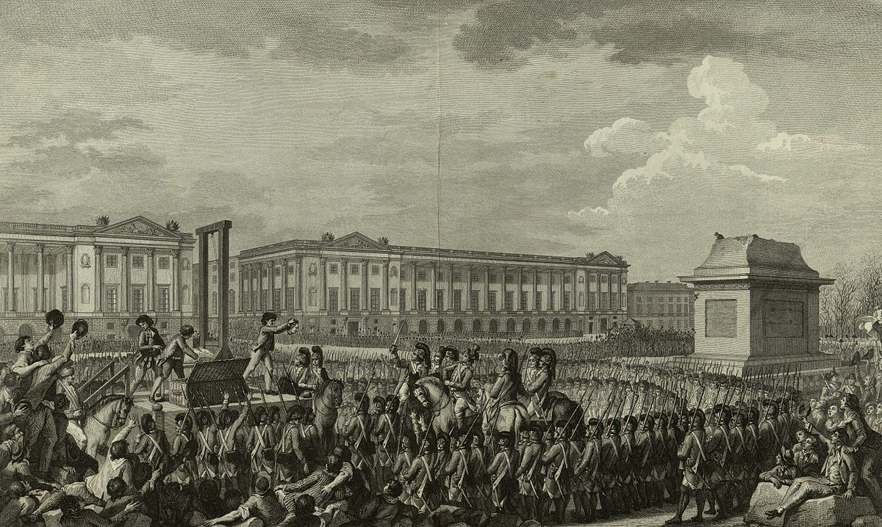

“Day of 21 January 1793 the death of Louis Capet (Louis XVI) on the Place de la Révolution"

1. How is the image of execution connected to the Constitution of 1791?
2. How is the image of execution connected to the wars with Austria and Prussia?