Making a Leader
"How many look up to him [Hitler] with touching faith as their helper, their savior, their deliverer from unbearable distress."
Louis Solmitz, Hamburg schoolteacher, 1932
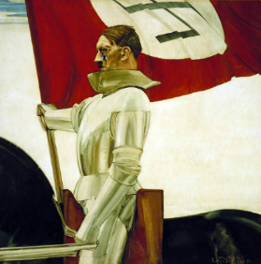
Intense public desire for charismatic leaders offers fertile ground for the use of propaganda. Through a carefully orchestrated public image of Nazi Party leader Adolf Hitler, during the politically unstable Weimar period the Nazis exploited this yearning to consolidate power and foster national unity. Nazi propaganda facilitated the rapid rise of the Nazi Party to political prominence. Election campaign materials from the 1920s and early 1930s, compelling visual materials, and controlled public appearances coalesced to create a "cult of the Führer" (leader) around Hitler. His fame grew via speeches at rallies, parades, and on the radio. Nazi propagandists cast Hitler as a military leader, a father figure, and a messianic leader brought to redeem Germany.

Rallying the Nation
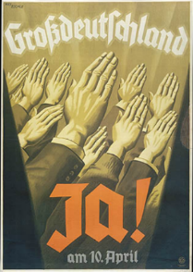
"The goal of our propaganda is control of the government. We want to replace the organization with a state founded upon the [National Socialist] idea."
Joseph Goebbels, 1927
Nazi propagandists appealed to popular desires for order by advertising the party as a protest movement against the instability and ineffectiveness of the "Weimar system." Indeed, from 1919 through the worldwide Depression that began in 1929, no single German political party was able to establish a parliamentary majority. Disagreements over economic policies, as well as the growing opposition between political parties, prevented a workable coalition. Instead, a succession of chancellors governed by presidential decree through Article 48 of the Weimar constitution, established to preserve democracy in times of unrest.

Indoctrinating Youth
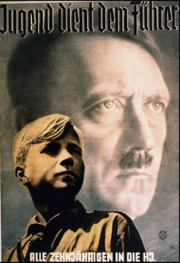
"These boys and girls enter our organizations [at] ten years of age, and often for the first time get a little fresh air; after four years of the Young Folk they go on to the Hitler Youth, where we have them for another four years . . . And even if they are still not complete National Socialists, they go to Labor Service and are smoothed out there for another six, seven months . . . And whatever class consciousness or social status might still be left . . . the Wehrmacht [armed forces] will take care of that."
-Adolf Hitler, 1938
From the 1920s onwards, the Nazi Party targeted German youth as a special audience for its propaganda messages. These messages emphasized that the Party was a movement of youth: dynamic, resilient, forward-looking, and hopeful. Millions of German young people were won over to Nazism in the classroom and through extracurricular activities.

Defining the Enemy
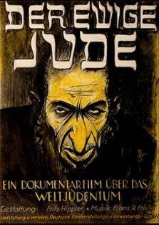
"I became a National Socialist because the idea of the National Community inspired me. What I had never realized was the number of Germans who were not considered worthy to belong to this community."
-Postwar memoirs of a German woman active in Nazi youth programs
One crucial factor in creating a cohesive group is to define who is excluded from membership. Nazi propagandists contributed to the regime's policies by publicly identifying groups for exclusion, justifying their outsider status, and inciting hatred or cultivating indifference. Nazi propaganda was crucial in selling the myth of the "national community" to Germans who longed for unity, national pride and greatness, and a break with the rigid social stratification of the past. But a second, more sinister aspect of the Nazi myth was that not all Germans were welcome in the new community. Propaganda helped to define who would be excluded from the new society and justified measures against the "outsiders."

Writing the News
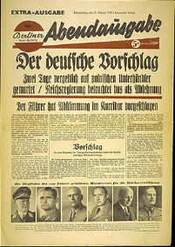
Reflecting in his diary (April 14, 1943) during the war on the press's loss of independence, Joseph Goebbels, a one-time journalist, wrote:
"Any man who still has a residue of honor will be very careful not to become a journalist."
When Hitler came to power in 1933, Germany had a well-developed communications infrastructure. Over 4,700 daily and weekly newspapers were published annually in Germany, more newspapers than in any other industrialized nation, with a total circulation of 25 million. Although Berlin was the press capital, small town presses dominated newspaper circulation (81% of all German newspapers were locally owned). Eight papers published in larger cities, however, had established international reputations. Germany's movie industry ranked among the world's largest, its films had won international acclaim, and it had pioneered in the development of both radio and television.
All of Poland in a War Fever
Terror by Poles [against ethnic Germans] Grows Day by Day

Deceiving the Public
"Common sense could not understand that it was possible to exterminate tens and hundreds of thousands of Jews,"
Yitzhak Zuckerman, a leader of the Jewish resistance in Warsaw, observed.
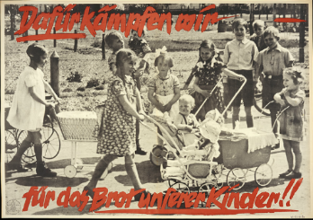
Propaganda served as an important tool to win over the majority of the German public who had not supported Hitler and to push forward the Nazis' radical program, which required the acquiescence, support, or participation of broad sectors of the population. Combined with the use of terror to intimidate those who did not comply, a new state propaganda apparatus headed by Joseph Goebbels sought to manipulate and deceive the German population and the outside world. At each step of the way, propagandists preached an appealing message of national unity and a utopian future that resonated with millions of Germans and, simultaneously, waged campaigns that facilitated the persecution of Jews and others excluded from the Nazi vision of the "National Community."
Why we fight—for our children's bread!!

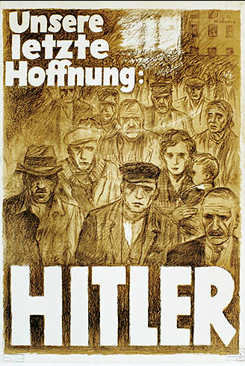 | Mjölnir [Hans Schweitzer], "Our Last Hope—Hitler," 1932  Mjölnir [Hans Schweitzer], "Our Last Hope—Hitler," 1932. In the presidential elections of 1932, Nazi propagandists appealed to Germans left unemployed and destitute by the Great Depression with an offer of a savior.
Der Bannerträger ("The Standard Bearer"), by Hubert Lanzinger, circa 1935  This portrait depicts Hitler as a messianic figure gazing toward a better future for Germany, with the Nazi flag billowing behind him. Austrian-born artist Lanzinger (1880-1950) painted this work in oils on a wood panel. It was first displayed at the Great German Art Exhibition in Munich in 1937. Some say that Hitler himself picked this image after being dismayed by the other selected artwork. Heinrich Hoffmann, Hitler’s official photographer and an exhibition judge, had the image made into a postcard around 1938. After the war, a U.S. soldier pierced the painting with a bayonet. It was then transferred to the U.S. Army Art Collection, German War | 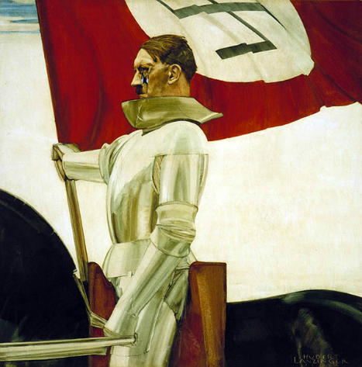
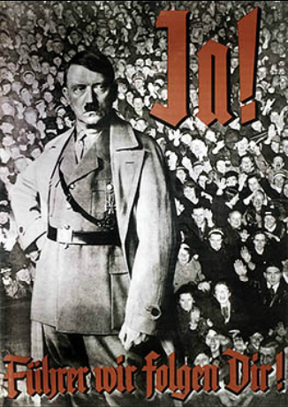 | Nazi Party Reich Propaganda Directorate, "Yes! Leader, We Follow You!"  Nazi propaganda constantly reinforced the notion that Hitler was the embodiment of the national will. Here, a determined looking Hitler in military dress stands with clenched fist, poised for action above the adoring crowd. This poster, designed for a 1934 public referendum on uniting the posts of German chancellor and president, conveys unanimous popular support for Hitler.
Poster: "We will take the fate of the nation into our hands…"  This poster from the 1932 campaign reads: "We will take the fate of the nation into our hands! Hitler will be Reich President!" | 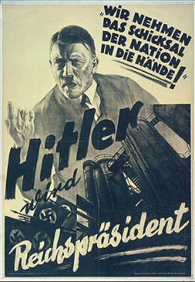
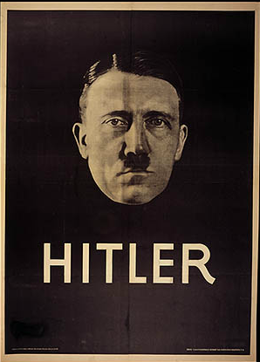 | Poster using a photo of Adolf Hitler by his official photographer, Heinrich Hoffmann  Modern techniques of propaganda—including strong images and simple messages—helped propel Austrian-born Adolf Hitler from being a little known extremist to one of the leading candidates for Germany's presidency in 1932. Heinrich Hoffmann, Hitler’s official photographer, created this 1932 election poster. The style of this poster is similar to those of some film stars of the era.
Shop window in Nuremberg displaying Hitler busts for sale, 1935  The cult of Adolf Hitler was promoted on a mass scale. Paintings, posters, and busts of the Führer were reproduced in huge quantities for display in public venues and private homes. Millions of copies of Hitler's 1924 autobiography, Mein Kampf (My Struggle), were published in special editions, including one for newlyweds and one in Braille for blind persons. | 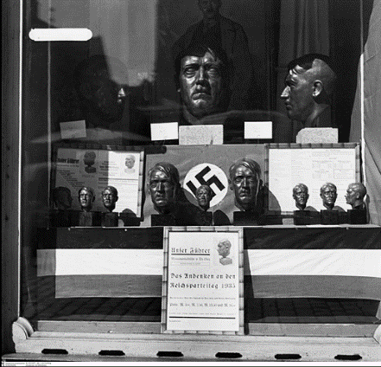

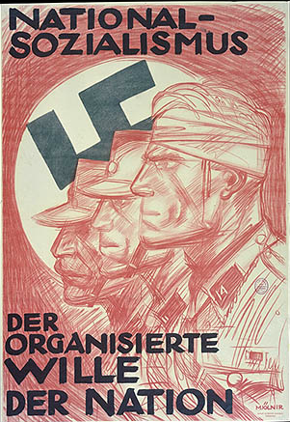 | Early Nazi campaign poster by Mjolnir: "National Socialism–The Organized Will of the Nation"  In the struggle to seize power, Nazi propagandists sought to win the "moral contest" by portraying its Storm Troopers who had been wounded in street brawls with Communists and Socialists, as victims rather than instigators. Bandaged Nazi warriors became a standard image in newspapers, films, and posters such as this one. Terrified of Communism, many in the German middle classes uncritically accepted this view of the Nazi as the courageous victim of leftist terror.
An idealized German family sheltered beneath the outstretched wings of the German eagle  Poster encouraging Germans to become involved in the activities of the local Nazi Party organization. The illustration depicts an idealized German family sheltered beneath the outstretched wings of the German eagle. The text reads: "The NSDAP protects the people. Your fellow comrades need your advice and help, so join the local party organization." | 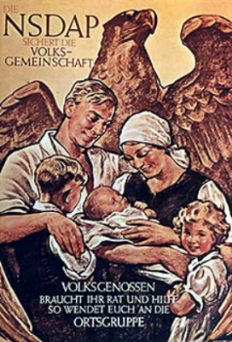
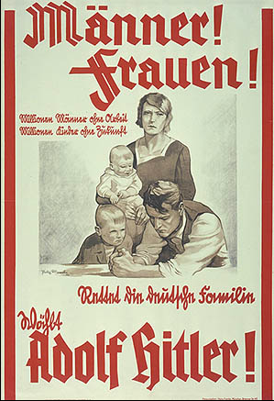 | Poster: "Women! … Save the German family. Vote for Adolf Hitler!"  Poster by Felix Albrecht. The text on the poster reads: "Women! Millions of men without work. Millions of children without a future. Save the German family. Vote for Adolf Hitler!"  Poster by Felix Albrecht. The text on the poster reads: "Women! Millions of men without work. Millions of children without a future. Save the German family. Vote for Adolf Hitler!"
Poster: "We're for Adolf Hitler!"  Poster: "We’re for Adolf Hitler!" This poster was aimed at unemployed miners. Nazi propaganda targeted specific subgroups in the German population with messages specially crafted to speak to a group’s desires, hopes, and needs. This poster appears to imply that a vote for Hitler will mean an end to unemployment for this group. | 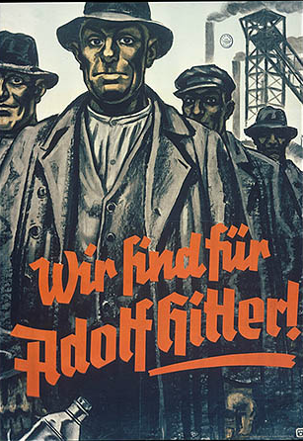
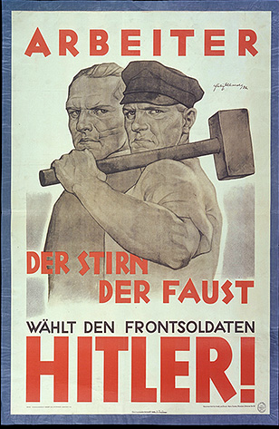 | Poster: "Workers of the Mind, of the Fist, Vote for the Front Soldier / HITLER!"  Nazi propagandists distinguished themselves from their leftist opponents by reaching out to both industrial workers "of the fist" and white-collar workers "of the mind." This 1932 presidential election poster also highlights the patriotic appeal of Hitler's status as a World War I veteran. Felix Albrecht, artist; 1932
Poster: "Greater Germany: Yes on 10 April" (1938)  This election poster emphasizes the message of jumping on the Nazi political bandwagon, as represented by the hands raised in a unified Nazi salute. Nazi propaganda frequently stressed the power of a mass movement to propel the country forward, subtly underscored by the upward angle of the hands. This poster typifies the propaganda strategy of using simple confident slogans, with bold graphics often using the characteristic Nazi colors of red, black, and white. | 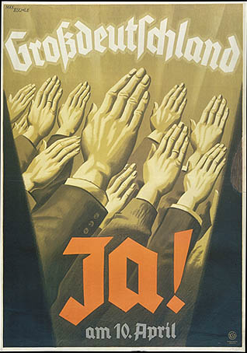

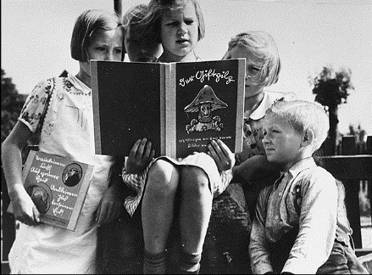
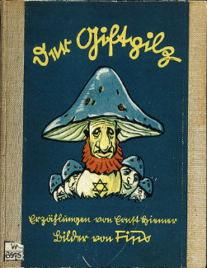
German children reading an antisemitic schoolbook
Black and white image of German children reading an antisemitic schoolbook, Der Giftpilz (The Poisonous Mushroom). Der Stürmer commentary reads: "With enthusiasm the children read "The Poisonous Mushroom." This photograph was used in advertisements for The Poisonous Mushroom.

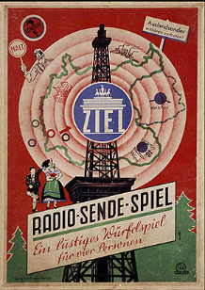
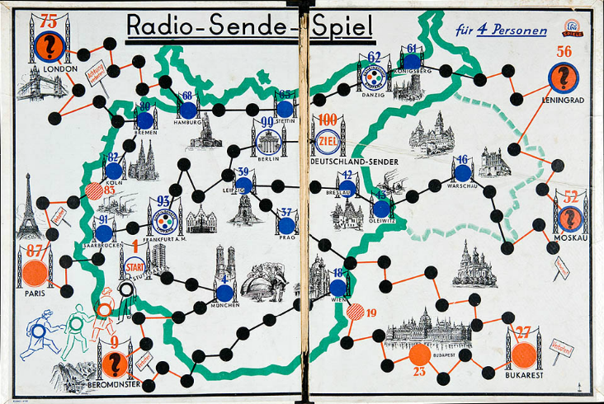
Board game encouraging players to listen to German radio stations
This German board game encouraged players to listen to German radio stations while punishing those who landed on a foreign radio station.
Toy figures representing Adolf Hitler and Nazi storm troopers  Toy figures representing Adolf Hitler and Nazi storm troopers helped attract a young audience to the party's activities. | 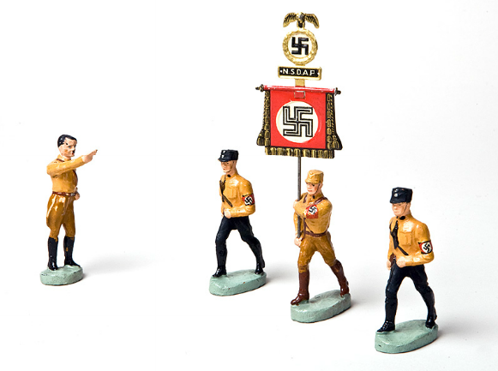
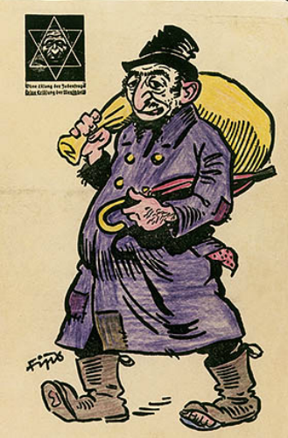 | Page from an antisemitic coloring book  One page of an antisemitic coloring book widely distributed to children with a portrait of a Jew drawn by the German caricaturist known as Fips. In the upper left hand corner is the Der Stürmer logo featuring a Star of David superimposed over a caricature of a Jewish face. The caption under the star reads: "Without a solution to the Jewish question, there will be no salvation for mankind."
Poster: "You too belong to the Führer"  Propaganda such as this poster emphasized that the goal of the League of German Girls was to prepare its young members for the role in German society specified for them by Nazi ideology: wife, mother, housewife, and communal volunteer. | 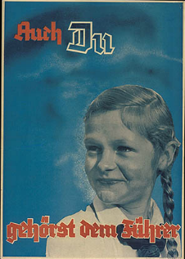

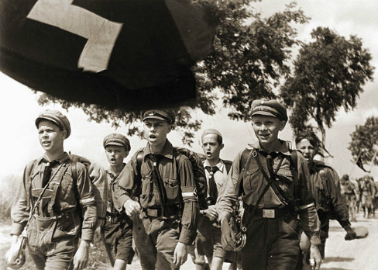 | Members of the Young Folk of the Hitler Youth at a vacation camp  The Young Folk program of the Hitler Youth emphasized outdoor group activities to build strong bodies and encourage comradeship. Here, members of the Young Folk sing as they march at a vacation camp. Such camping trips were particularly welcomed by boys from Germany's large urban areas.
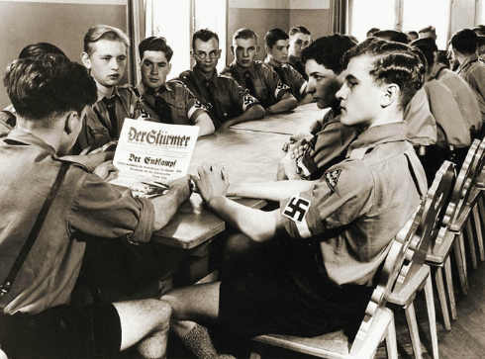 | Hitler Youth group meeting  Hitler Youth were organized into local groups that held weekly meetings that included political indoctrination. Here, a troop leader reads to his fellow Hitler Youth during a social evening. 1937.
Members of the League of German Girls paste up a recruiting poster  Members of the League of German Girls paste up a recruiting poster urging young women to join their ranks Nazi activists understood the importance of peer pressure as a motivating factor for mass recruitment to the Nazi movement, which emphasized collective social harmony and sacrifice for the greater good of the nation. | 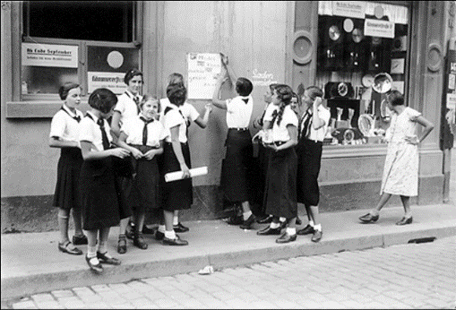
After-school activities for member of League of German Girls  A typical after-school activity for members of the League of German Girls was to take children from large families for an airing in the park while the mothers of the infants were at work. | 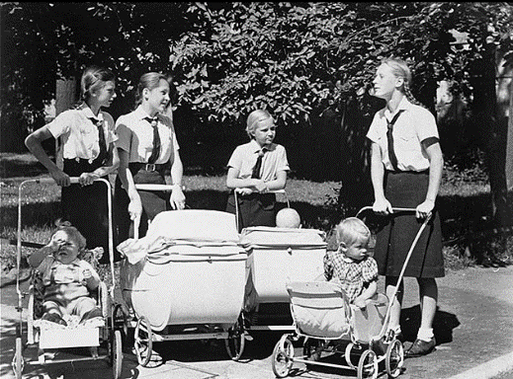

Front page of the most popular issue ever of the Nazi publication, Der Stürmer  Front page of the most popular issue ever of the Nazi publication, Der Stürmer, with a reprint of a medieval depiction of a purported ritual murder committed by Jews. | 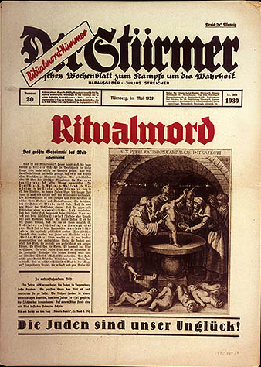
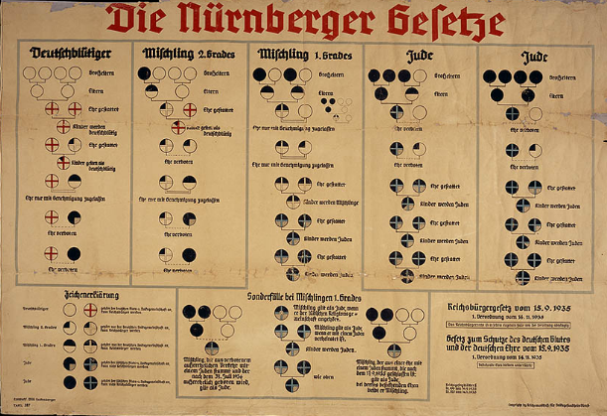 | Nuremberg race laws chart  These so-called Nuremberg Laws, named for the city in which they were announced, legally separated Jews from Germans
Poster: "He is guilty for the war"  1943 anti-Jewish poster by the artist "Mjolnir" intended to persuade Germans that Jews were responsible for starting the war. "Mjolnir" was the pen name of the artist Hans Schweitzer who created many of the most popular Nazi propaganda posters. | 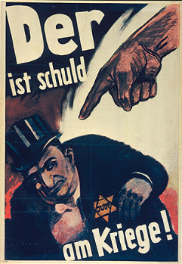
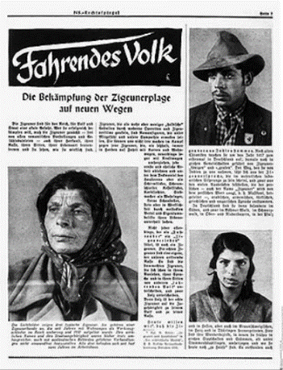 | Anti-Roma (Gypsy) propaganda  Page of a propaganda article titled "Vagabonds: New Ways of Combating the Gypsy Plague." Campaigns against the Roma exploited racial prejudice and popular stereotypes to justify their arrest and internment.
Propaganda slide depicting "loss of racial pride"  This propaganda slide depicts friendship between an Aryan woman and a black woman as a loss of racial pride. The caption says: "The experience/Racial pride fades." Germany, ca. 1933-1939. | 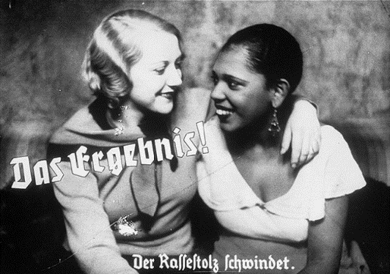
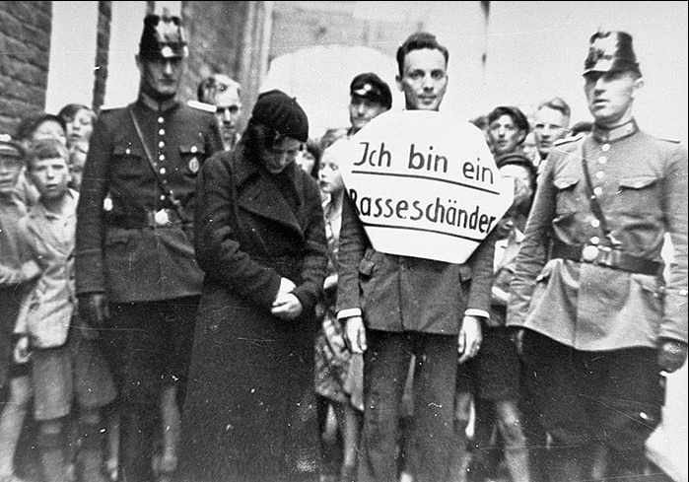 | Public humiliation: "I am a defiler of the race"  In this photograph, a young man who allegedly had illicit relations with a Jewish woman is marched through the streets for public humiliation. Flanked by German police officers, he wears a sign that reads, "I am a defiler of the race." These events were calculated to both punish the so-called offenders and to make a public example of them as a deterrent to others who might not fully subscribe to Nazi racial theory. Norden, Germany, July 1935.

Das Juedische Volk [The Jewish people] of February 1933  Das Juedische Volk of February 1933. Published immediately after the Nazi rise to power, this monthly, which took a strong anti-Nazi stand, was shut down one month later. | 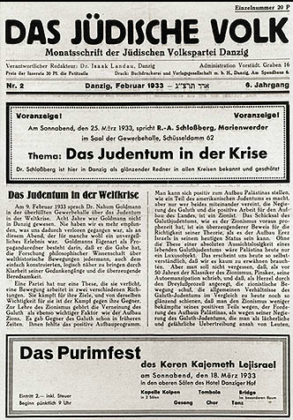
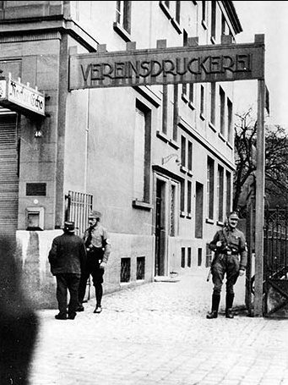 | SS and SA block offices of Social Democratic newspaper  Members of the SS and SA block the entrances to the printing offices of the opposition Social Democratic newspaper, the Neckar Echo, in Heilbronn (March 12, 1933).
Headlines from German press  The German propaganda campaign against Warsaw climaxed in the days before the invasion, featuring such headlines as "All of Poland in a War Fever," "Terror by Poles [against ethnic Germans] Grows Day by Day / Polish Bandits Murder Five-Month-Old Infant," and "Poland Rejects Negotiations." This Völkischer Beobachter headline reads: "The German Proposal / Two Days Waiting in Vain for Polish Negotiator / Reich Government Views as Refusal" | 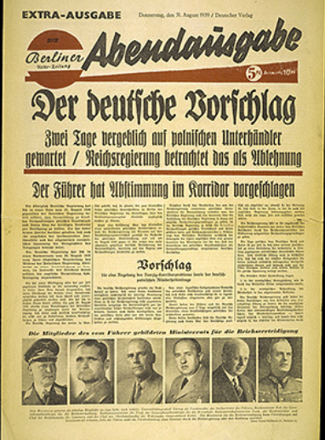
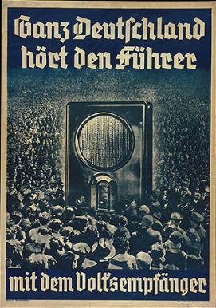 | Poster: "All of Germany Listens to the Führer with the People's Radio".  1936 poster: "All of Germany Listens to the Führer with the People's Radio." The poster depicts a crowd surrounding a radio. The radio looms large, symbolizing the mass appeal and broad audience for Nazi broadcasts.  Goebbels's ministry recognized the tremendous promise of radio for propaganda. It heavily subsidized the production of the inexpensive "People's Receiver" (Volksempfänger) to facilitate sales. By early 1938, the number of radios in German homes surpassed more than 9 million, roughly one for every two German households. Three years later, this figure rose to almost 15 million, providing 50 million Germans with regular radio reception.
A German couple reads the latest issue of Der Stürmer  A German couple reads the latest issue of Der Stürmer, posted on the sidewalk in the standard 3-section display case. | 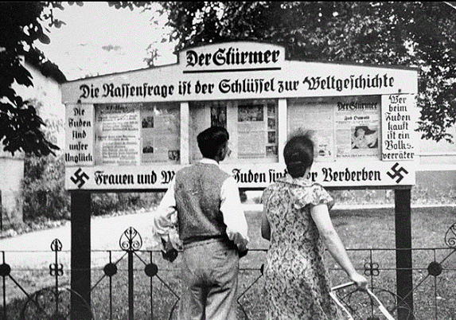
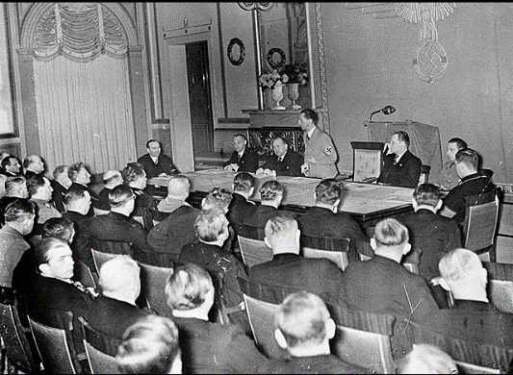 | Joseph Goebbels delivers a speech to his deputies for the press and the arts in the Propaganda Ministry  The Reichskulturkammer (Reich Culture Chamber) was established for the Gleichschaltung ("coordination") of the media. Joseph Goebbels was its president. In this photograph, Goebbels delivers a speech to his deputies for the press and the arts in the auditorium of the Propaganda Ministry. Berlin, Germany, 1936.

