http://www.npr.org/2017/01/24/511402501/trump-to-give-green-light-to-keystone-dakota-access-pipelines

POLITICS

Trump To Give Green Light To Keystone, Dakota Access Pipelines
January 24, 201710:33 AM ET
BRIAN NAYLOR
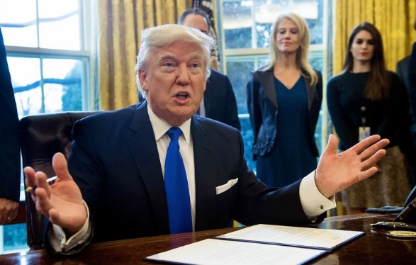
President Trump speaks before signing documents in the Oval Office related to the Dakota Access and Keystone pipelines on Tuesday.
Nicholas Kamm/AFP/Getty Images

President Trump on Tuesday gave the go-ahead for construction of two controversial oil pipelines, the Keystone XL and the Dakota Access.
As he signed the paperwork in an Oval Office photo op, Trump said his administration is "going to renegotiate some of the terms" of the Keystone project, which would carry crude oil from the tar sands of western Canada and connect to an existing pipeline to the Gulf Coast.
The pipelines had been stopped during the Obama administration. The State Department rejected a permit for the Keystone XL pipeline, and President Obama ordered work halted on the Dakota pipeline after Native American groups and other activists protested its route near culturally sensitive sites in North Dakota.
Trump said the Keystone XL pipeline will mean "a lot of jobs, 28,000 construction jobs, great construction jobs."

Proposed And Existing TransCanada Pipelines
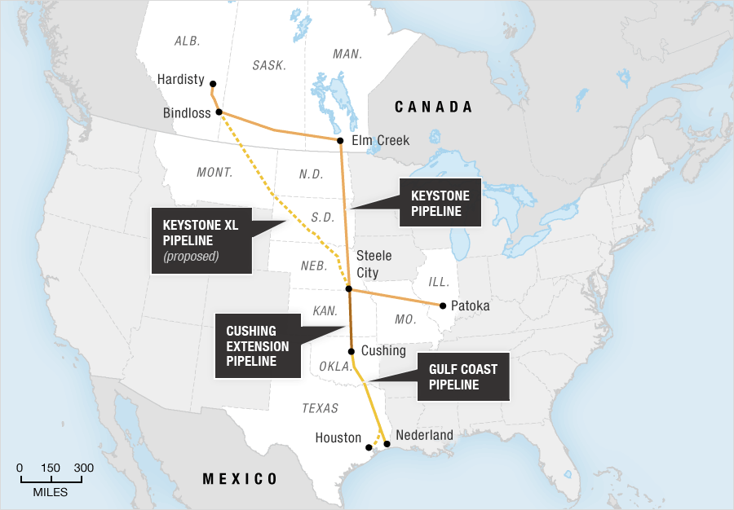
Source: TransCanada
Credit: Stephanie d'Otreppe and Alyson Hurt / NPR

He also signed a decree that the pipelines will be built with American steel, "like we used to in the old days," and two others: one that he said will streamline "the incredibly cumbersome, long, horrible permitting process and reducing regulatory burdens for domestic manufacturing," and another he says will expedite environmental reviews and approvals "for high-priority infrastructure projects."
"We can't be in an environmental process for 15 years if a bridge is going to be falling down or if a highway is crumbling," Trump said.
The president's actions quickly reignited the debate over the pipelines; supporters say the pipelines will lead to lower energy costs and create jobs, while environmentalists argue they will lead to the release of more climate-warming carbon into the atmosphere.
The reaction from lawmakers was swift. Independent Sen. Bernie Sanders of Vermont said Trump's actions to advance the pipelines will "put the short-term profits of the fossil fuel industry ahead of the future of our planet."
But North Dakota Democratic Sen. Heidi Heitkamp said Trump's actions "are a needed step" toward the goal of an all-of-the-above North American energy strategy.
The Standing Rock Sioux Tribe, which protested the Dakota Access pipeline, said it will take legal action to fight Trump's decision, saying the pipeline "risks contaminating tribal and American water supplies while disregarding treaty rights."
In remarks to automakers on Tuesday morning, Trump proclaimed himself an environmentalist, but added, "It's out of control, and we're going to make a very short process, and we're going to either give you your permits or we're not going to give you your permits, but you're going to know very quickly."

http://www.foxnews.com/politics/2017/01/24/trump-to-sign-orders-reviving-pipeline-projects-sources-say.html

WHITE HOUSE

Trump to sign orders reviving pipeline projects, sources say
Published January 24, 2017
FoxNews.com
President Trump plans to sign executive orders reviving the Keystone XL and Dakota Access pipelines, which had been stalled under the Obama administration, sources tell Fox News.
The moves had been widely expected, as Trump blasted his predecessor for effectively blocking the projects amid environmental and other concerns.
While the Canada-to-Texas Keystone project was at the center of a heated debate for years until the Obama administration rejected a key permit in November 2015, the Dakota pipeline more recently became the subject of fierce protests until the Army Corps of Engineers in December blocked construction of a controversial segment.
The company behind the Keystone XL project, TransCanada, has not yet reapplied for a pipeline permit, after having withdrawn its request under the Obama administration.
The expected moves come as Trump makes the economy and jobs the centerpiece of his administration’s first week in office.
He met Tuesday morning with representatives from the auto industry including GM and Ford, after meeting a day earlier, separately, with business and union leaders.
The pipelines were one of the few issues that put the Obama administration at odds with labor unions, some of whom have voiced hope the Trump administration can work with them to promote job creation. Trump said Tuesday during his meeting with auto industry bosses that he considers himself an environmentalist, but called current regulations "out of control."
The pipeline orders would follow earlier executive actions covering everything from trade to ObamaCare.
Trump on Monday signed measures withdrawing the U.S. from the Trans-Pacific Partnership trade deal, and instituting a hiring freeze for most of the federal government.
Fox News’ John Roberts contributed to this report.

http://www.bbc.com/news/world-us-canada-38734450

Trump 'to advance controversial pipelines'

Bottom of Form
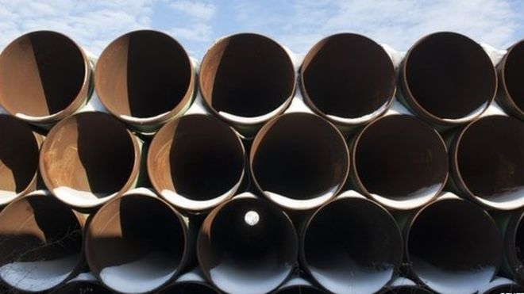
Image copyright REUTERS Image caption A depot used to store Keystone pipes in North Dakota
US President Donald Trump will back two controversial pipelines by executive order on Tuesday, US media report.
The new Republican president is expected to support the Keystone XL and Dakota Access pipelines.
The Obama administration in late 2015 halted Keystone, which would carry crude from Canada to US refineries on the Gulf Coast.
The Army decided last year to explore other routes for the Dakota pipeline amid huge protests by Native Americans.
Keystone XL pipeline: Why is it so disputed?
Dakota Pipeline: What's behind the controversy?
Environmental groups reacted with outrage to news of Mr Trump's planned executive action.
Greenpeace director Annie Leonard said that "instead of pushing bogus claims about the potential of pipelines to create jobs, Trump should focus his efforts on the clean energy sector where America's future lives".
President Trump, who took office on Friday, promised during his White House campaign to support Keystone XL and fossil fuels, including the flagging US coal industry.

More than just a pipeline - Analysis by Anthony Zurcher, Washington DC
Over the course of the Obama presidency, the Keystone XL Pipeline became more than just another energy industry construction project. It grew into a high-profile proxy fight between environmentalists and oil-and-gas advocates; liberals and conservatives; pro-regulation activists and small-government true believers.
On the campaign trail Donald Trump often cited the Obama administration's reluctance to green-light the project as prima facia evidence of the Democratic Party's anti-business attitudes. Now, with the swipe of a pen, he's set make it much easier for the project to be completed - assuming the involved company still wants it.
Perhaps of more immediate concern is Mr Trump's move to fast-track approval of the Dakota Access Pipeline, which was the focus of vigorous protests from Native American tribes in 2016. Unlike Keystone, that project has not been held in limbo for years.
Mr Trump's actions do not mean the end of the fight over US pipeline construction, however. Opponents will continue to argue that they jeopardise sensitive environmental areas and violate private property rights. Now, however, instead of appealing to a potentially friendly Democratic administration, they will take the battle to the courts.
Image copyright GETTY IMAGES Image caption Protests in North Dakota were led by the Standing Rock Sioux tribe
But during a Tuesday morning meeting with automobile executives at the White House, Mr Trump described himself as an environmentalist.
On Monday, he made similar comments to other business leaders, saying: "I'm a very big person when it comes to the environment. I have received awards on the environment."
Canada lobbied hard for years for the approval of the Keystone XL pipeline under former-Prime Minister Stephen Harper, who once said that authorising the new oil sands pipeline was a "complete no-brainer".
His successor, Prime Minister Justin Trudeau, also supports the project and has said he intends to work with President Trump to approve the pipeline, proposed by Calgary-based energy infrastructure giant TransCanada.
On Tuesday, Canada's natural resources minister praised Mr Trump's step as very positive for Canada.
Keystone XL would carry Canadian oil sands crude 1,179 miles from Alberta to Texas.
The planned Dakota Access pipeline would run 1,100 miles (1,770km) from North Dakota to Illinois.
http://www.aljazeera.com/news/2017/01/trump-clear-keystone-xl-dakota-access-pipelines-170124145605155.html

Trump 'to clear' Keystone XL, Dakota Access pipelines

Two controversial projects that were rejected by Obama will go ahead with Trump's approval, Bloomberg media reports.
US President Donald Trump is due to sign two executive actions to advance the building of the Keystone XL and Dakota Access pipelines, according to US media.
The signing was expected on Tuesday, Reuters news agency reported, citing Bloomberg media.
The steps illustrate Trump's plan to give the oil industry more freedom to expand infrastructure and ease transportation bottlenecks.
Former President Barack Obama rejected Transcanada Corp's Keystone XL oil pipeline in November 2015 after environmentalists campaigned against the project for more than seven years.
The pipeline would run from Canada to US refineries in the Gulf Coast. The US government needed to approve the pipeline because it crossed the border.
The $3.8bn Dakota Access Pipeline has also faced opposition.
Activists have spent months protesting plans to route the pipeline beneath a lake near a North Dakota Indian reservation, saying the project poses a threat to water resources and sacred Native American sites.
Energy Transfer Partners, the company that wants to build the pipeline, disputed that and said it would be safe.
The pipeline is to carry North Dakota oil through South Dakota and Iowa to a shipping point in Illinois.
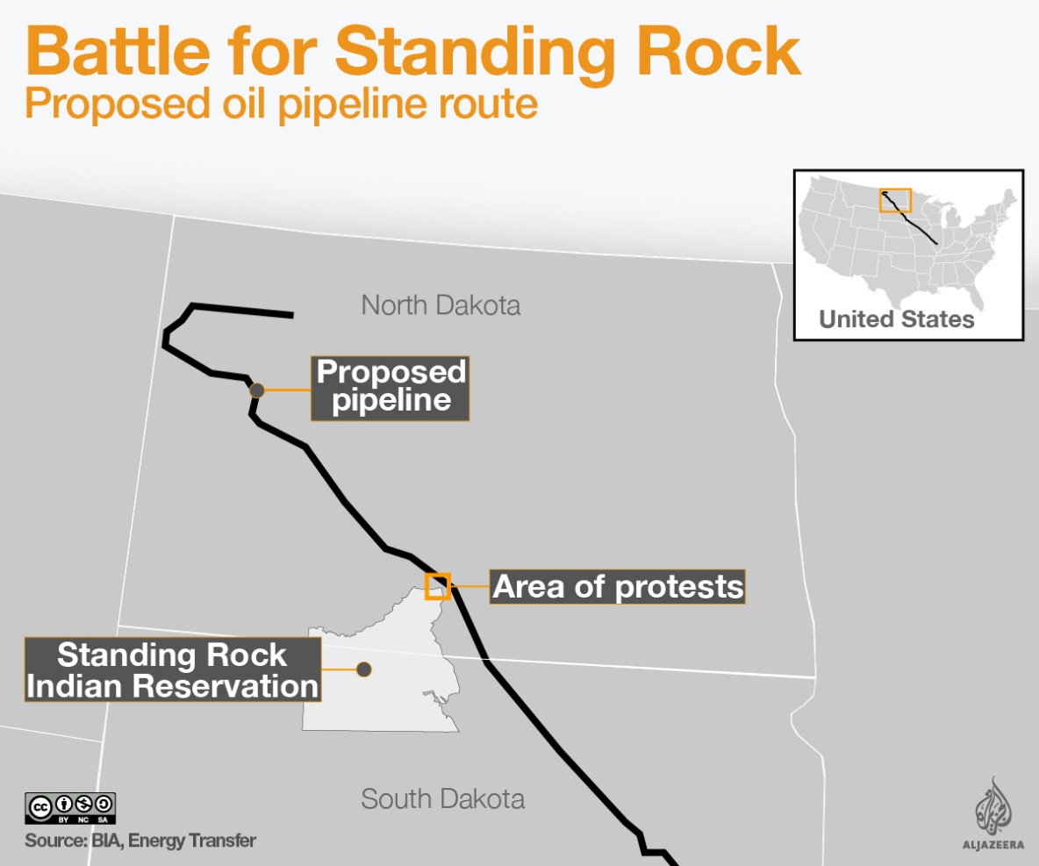

http://www.huffingtonpost.com/entry/trump-keystone-dakota-access_us_58877e02e4b070d8cad57814?
POLITICS

Trump Signs Executive Orders On Keystone XL,

Dakota Access Pipelines

The new president has long supported the fiercely protested oil pipelines.
01/24/2017 11:41 am ET | Updated 8 minutes ago
Alexander C. Kaufman Senior Business Editor, The Huffington Post
President Donald Trump signed executive orders on Tuesday to push forward the Keystone XL and Dakota Access pipelines, opening new fronts in his looming war with environmentalists.
Keystone was rejected in 2015 by former President Barack Obama after a seven-year review. Trump’s orders clear the way to continue building Energy Transfer Partners’ 1,172-mile Dakota Access project, which has been stalled since the U.S. Army Corps of Engineers halted construction in December amid massive protests led by the Standing Rock Sioux.
“This is with regard to the construction of the Keystone pipeline, something that has been in dispute, and subject to a renegotiation of terms by us,” Trump said of the first action during a signing broadcast on TV networks Tuesday morning. “We’re going to renegotiate some of the terms and if they would like, we will see if we can get that pipeline built. A lot of jobs, 28,000 jobs. Great construction jobs.”
Trump then signed the second action.
“This is with respect to the construction of the Dakota Access Pipeline,” he said, introducing the leather-bound order. “Again, subject to terms and conditions to be negotiated by us.”
Another action signed Tuesday calls for U.S. steel to be used if the pipelines are built, though that may mean little in the case of the Dakota Access Pipeline, which is nearly complete. One more order aims to overhaul what Trump called the “horrible permitting process” by slashing environmental regulations.
“If we’re going to build pipelines in the United States, the pipelines should be built in the United States,” Trump said. “We’re going to put a lot of workers, a lot of steelworkers back to work. We will build our own pipes, we will build our own pipelines, like we used to in the old days.”
The moves mark the first serious step by the new president to reverse his predecessor’s environmental gains in favor of propping up an oil and gas industry dogged by low prices, competition from renewable energy and regulations aimed at cutting carbon emissions. Republicans, who pushed Obama to greenlight both pipelines, hailed the orders as a victory.
“The unfortunate reality is that these important infrastructure projects were used by special interests to advance their radical anti-energy agenda and were therefore needlessly halted by the last administration—to the detriment of America’s national interest,” House Speaker Paul Ryan (R-Wis.) said. “These pipelines will strengthen our nation’s energy supply and help keep energy costs low for American families.”
The day after Trump’s surprise election victory, TransCanada, the company behind the Keystone XL, announced plans to meet with the incoming administration to once again pitch the proposed 1,179-mile oil conduit from Alberta to Nebraska. The firm has yet to reapply for the project.
Trump said in May he would support the Keystone pipeline if the U.S. government could get a share of its revenue, which may not be legal. But Trump’s vow to renegotiate the 1993 North American Free Trade Agreement, on which he plans to sign an executive order this week, could complicate things. In June, TransCanada sued the U.S. government through a legal clause in NAFTA.
Still, Keystone XL may prove easier than the Dakota Access Pipeline to build ― the State Department handles large parts of the permitting process because the conduit crosses a border, Daniel Riesel, senior partner at the environmental law firm Sive, Paget & Riesel, told The Huffington Post.
The pipeline would largely pump oil from tar sands ― a noxious mix of sand, clay and bitumen, a thick, viscous oil ― to refineries on the Gulf coast of Texas. Keystone XL would carry 830,000 barrels of tar sand oil, considered one of the dirtiest fossil fuels, into the U.S. daily, producing emissions equivalent to putting 5.6 million new cars on the road, according to estimates by the environmental nonprofit Friends of the Earth.
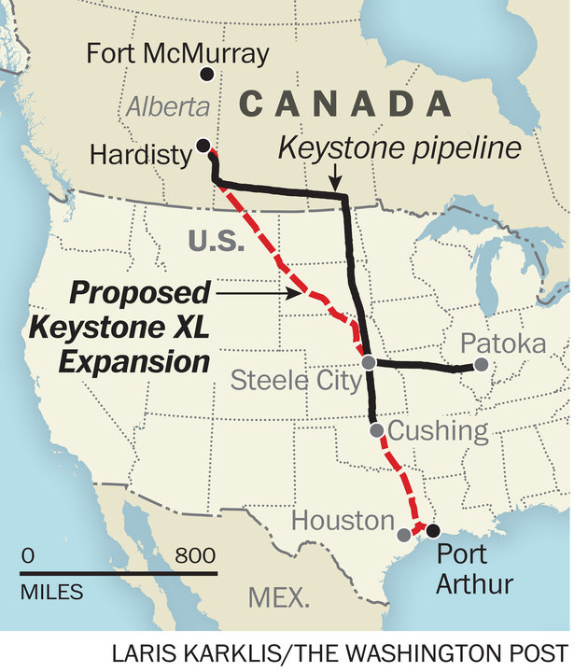
THE WASHINGTON POST VIA GETTY IMAGES
A map shows where the Keystone XL, an extension of the existing Keystone pipeline, would run.
The project, which drew opposition from a broad coalition of conservation and climate advocates, would likely renew lawsuits and protests to stop construction.
“This is not a done deal,” Bill McKibben, co-founder of the environmenalist group 350.org, said in a statement. “The last time around, TransCanada was so confident they literally mowed the strip where they planned to build the pipeline, before people power stopped them. People will mobilize again.”
The Dakota Access Pipeline may face less intense resistance. Protesters hailed victory in December when the Army denied a permit for the $3.8 billion project to build under North Dakota’s Lake Oahe, a sacred body of water to the Native American tribes who live there. The pipeline, meant to carry crude from the Bakken oil field, is mostly complete, save for a stretch near the Standing Rock Sioux reservation. Even as temperatures in the massive protest camp near the dig site fell below zero, legions of protesters ― including 2,000 veterans who came to serve as “human shields” ― remained.
But on Friday, Standing Rock leaders asked protesters to decamp as the tribe plans to continue its fight against the pipeline in the courts. The protesters, who called themselves “water protectors,” have until Jan. 30 to leave the main camp, according to a resolution unanimously passed by the Standing Rock Sioux Tribal Council in Fort Yates, North Dakota.
“Moving forward, our ultimate objective is best served by our elected officials, navigating strategically through the administrative and legal processes,” the Standing Rock Sioux Tribe said in a statement posted to Facebook, where the hashtag #NoDAPL went viral over the summer. “For this reason, we ask the protectors to vacate the camps and head home with our most heartfelt thanks.”
Creating a second Flint does not make America great again.Dave Archambault II, chairman of the Standing Rock Sioux Tribe
Soon after Trump signed the orders, Earthjustice, the legal nonprofit representing the Standing Rock Sioux in court, vowed to challenge the actions. The group noted that Trump used to own a stake in the pipeline’s developer. Though Trump sold the stake in December, Earthjustice believes it could still provide a means to fight the pipeline on ethics grounds.
“This move is legally questionable, at best,” Earthjustice President Trip Van Noppen said in a statement. “[Trump] should brace himself to contend with the laws he is flouting, and the millions of Americans who are opposed to these dangerous and destructive projects. We will see his administration in court.”
The existing pipeline route risks contaminating water used by the tribe and by 17 million Americans downstream, said Dave Archambault II, chairman of the Standing Rock Sioux Tribe.
“We are not opposed to energy independence. We are opposed to reckless and politically motivated development projects, like DAPL, that ignore our treaty rights and risk our water,” he said.
Archambault then alluded to the lead-tainted water crisis in Flint, Michigan, saying, “Creating a second Flint does not make America great again.”
On Monday, with almost eerie timing, a pipeline in the western Canadian province of Saskatchewan leaked 52,834 gallons of oil on tribal lands, precisely illustrating the fears of protesters on the U.S. side of the border.
“Millions of people came together all over this country to stop the Keystone XL and Dakota Access pipelines and say we must transform our energy system away from fossil fuels to renewable energy,” Sen. Bernie Sanders (I-Vt.), who asked Trump’s Cabinet nominees some of the toughest climate questions during last week’s confirmation hearings, said Tuesday in a statement. “Today, President Trump ignored the voices of millions and put the short-term profits of the fossil fuel industry ahead of the future of our planet.”
Trump, who has incorrectly described climate change as a hoax invented by the Chinese, laid out a vision to kick-start the U.S. economy by slashing environmental regulations and boosting the oil, gas and coal industries. He has stacked his Cabinet with fossil fuel allies and climate science deniers, including in key positions that affect the environment.
During the first White House briefing in which he took questions from the press, press secretary Sean Spicer dodged a question from HuffPost on Monday about how Trump plans to address the fact that scientists say climate change is close to harming human civilization, given that 2016 was the hottest year on record.
“He’s going to meet with his team and figure out what policies are best for the environment,” Spicer said. “One of the things he talked about during the campaign is there’s a balance, and he’s trying to make sure we use our resources appropriately, that we maximize things to make sure that we don’t do so at the detriment of economic growth and job creation.”
Trump’s bet on dirty energy comes as China, the world’s biggest polluter, cancels plans for 103 new coal-fired power plants and urges Trump not to pull out of the historic climate accord reached in Paris in 2015.
“While countries like China and Germany continue to make progress in their transition away from the dirty energy of the past, this action will roll back the progress we have made,” Sen. Brian Schatz (D-Hawaii) said in a statement.
“Climate change is the challenge of our generation, and we need to be moving forward with policies to support clean energy,” Schatz went on. “The Keystone XL and Dakota Access pipelines are simply not in our national interest.”
This article has been updated.

