Journalism Comparison
“Our liberty depends on the freedom of the press,
and that cannot be limited without being lost.” Thomas Jefferson

Mass Media
Mass media uses various technologies to communicate to the general public whether to entertain, persuade, advertise, or inform. Print media was the earliest form, exemplified in books, magazines, newspapers, pamphlets. In the early twentieth century broadcast media became increasingly important as new inventions were introduced—film, recorded music, radio and television. More recently digital media is exerting greater influence with the development of the internet and mobile devices.

Journalism
News media is one part of the mass media that delivers news to the public through print, broadcast and digital technologies. Journalism is the activity of gathering, assessing, creating, and presenting news and information. Its value lies in providing the public with verified information so people can make better decisions. In its obligation to provide truth it has sought to be independent from influence and has often acted as a watchdog for abuse of power. Its commitment to quality information has also lent itself to be a forum for public discussion. This also makes it source of political debate and concern over bias. Below is a graph that shows trends of reporting in regards to quality of reporting on the vertical axis and political persuasion on the horizontal axis.
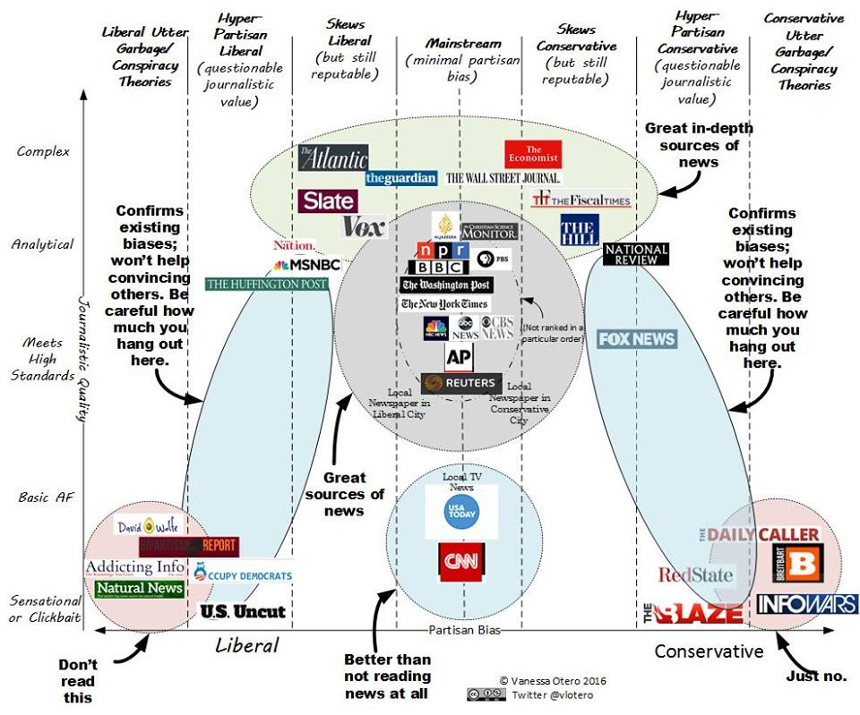

Collecting Sources
The increasing access to information through digital media requires a greater care in evaluating information. One needs to look at the quality of sources and compare sources. Your group task is to
- select a noteworthy news item
- have each member collect the coverage of the news item from the following sources: NPR, Fox News and Huffington Post, BBC, and Al Jazeera

Evaluating Sources
After collecting the reporting from various news outlets, you will need evaluate the quality of their reporting.
- Type: What kind of content is this — news, opinion, advertising or something else?
- Source: Who and what are the sources cited, and why should I believe them?
- Evidence: What’s the evidence and how was it vetted?
- Interpretation: Is the main point of the piece proven by the evidence?
- Completeness: What’s missing?
- Knowledge: Is there an issue here that I want to learn more about and where could I do that?

Comparing Sources
Evaluate the different sources by asking
- Do they rely on the same sources?
- What evidence do they all have in common?
- What is unique to each news media source?
- Are they making the same point? If not, why?

