In the Rubber Coils
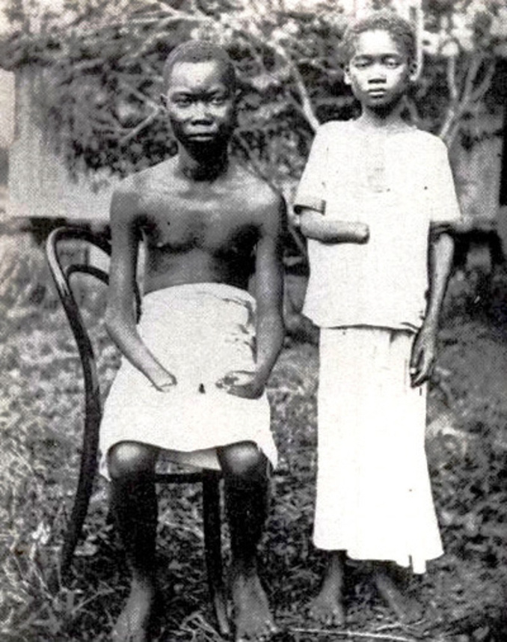
The imperialist powers saw Africa as a valuable source of raw materials that would fuel their growing economies. European businessmen made enormous profits by controlling the African trade in rubber, coffee, ivory, diamonds, palm oil, cotton, tea, and tobacco. Unfortunately, the drive for profit often led to incredible brutality and crimes against humanity.
In the Congo, for example, which was under the rule of the Belgian King Leopold, local people were forced to collect rubber and other natural resources. Missionaries reported that African workers were killed for failing to meet their quotas. Belgian agents collected amputated hands and sent them back to the king as proof that his strict policies were being enforced.

Examine the photo and answer the following questions.
- Why do you think these children are missing their hands? Who injured them and why?
Young victims of violence in the Congo
- Who do you think took this picture?
- For what audience was this picture intended? Why?
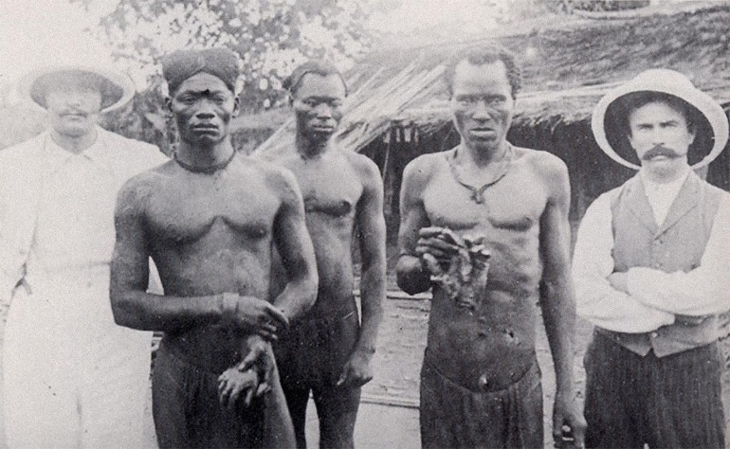
These British missionaries and these local Africans are upset about the actions of the Anglo-Belgian India Rubber Company (A.B.I.R.), whose militia has been cutting off hands from rubber workers.
Missionary poses with evidence of brutality
- Why does this company have its own militia?
- Why do you think A.B.I.R. militiamen cut off people’s hands?
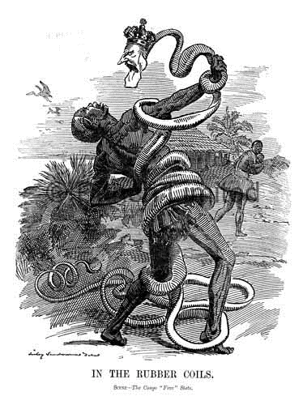
Look at the image and answer the following questions
- Which political figure is represented as a snake in this cartoon?
- Who do you think the intended audience was? Hint: look at the language of the caption.
- The original caption for this political cartoon from 1906 was “In the Rubber Coils.”
In the space below, design your own caption for the cartoon:
Caught up in the evils of the rubber trade
The picture above and the one on the previous page depict the situation in Belgian colonial Africa for a British audience.
- How might these images have been used to justify British imperialism?
- Do you think this is a contradiction? Why/Why not?

In the Rubber Coils
The imperialist powers saw Africa as a valuable source of raw materials that would fuel their growing economies. European businessmen made enormous profits by controlling the African trade in rubber, coffee, ivory, diamonds, palm oil, cotton, tea, and tobacco. Unfortunately, the drive for profit often led to incredible brutality and crimes against humanity.
In the Congo, for example, which was under the rule of the Belgian King Leopold, local people were forced to collect rubber and other natural resources. Missionaries reported that African workers were killed for failing to meet their quotas. Belgian agents collected amputated hands and sent them back to the king as proof that his strict policies were being enforced.
Examine the photo and answer the following questions.
- Why do you think these children are missing their hands? Who injured them and why?
The children are missing their hands because they are not meeting their quotas for the collection of rubber. It appears to be a form of intimidation to force Congolese into meeting their quotas.
Young victims of violence in the Congo
- Who do you think took this picture?
Missionaries took this picture to expose the abuse of the Congolese by Belgian agents.
- For what audience was this picture intended? Why?
The pictures were likely intended for other Europeans in order to put pressure on Belgium to stop these atrocities.
These British missionaries and these local Africans are upset about the actions of the Anglo-Belgian India Rubber Company (A.B.I.R.), whose militia has been cutting off hands from rubber workers.
Missionary poses with evidence of brutality
- Why does this company have its own militia?
The company likely needs a small army to control the population. Under these obscene conditions, Africans would likely want to flee or rebel
- Why do you think A.B.I.R. militiamen cut off people’s hands?
They wanted to keep Africans in a state of fear and control.
Look at the image and answer the following questions
- Which political figure is represented as a snake in this cartoon?
The head of the snake is a depiction of King Leopold II.
- Who do you think the intended audience was? Hint: look at the language of the caption.
Political cartoons are usually intedend to critique someone or something. Here the critique is of King Leopold II and the evils he is committing against the Congolese. The intended audience was other Europeans and most likely Britain.
- The original caption for this political cartoon from 1906 was “In the Rubber Coils.”
In the space below, design your own caption for the cartoon:
Caught up in the evils of the rubber trade
The picture above and the one on the previous page depict the situation in Belgian colonial Africa for a British audience.
- How might these images have been used to justify British imperialism?
By demonstrating how evil the Belgians were against the Congolese, the British were made to look more humane. The Belgian pretense of civilizing the “savages” was being unmasked. The British in their critique of Belgium would give others the impression that they were free of these abuses.
- Do you think this is a contradiction? Why/Why not?
Yes, there is a contradiction. While the British are not chopping off hands, they are also using extreme measures to exploit Africa of its resources. Using machine guns, they are forcibly pushing people off the land to steel diamonds and gold.

