Détente and Arms Control, 1969–1979
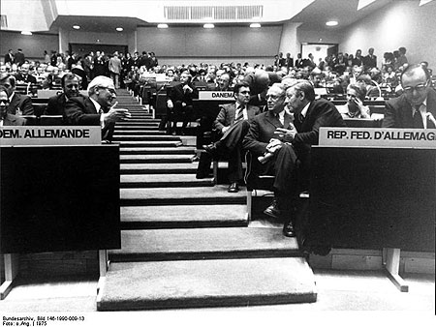
Between the late 1960s and the late 1970s, there was a thawing of the ongoing Cold War between the United States and the Soviet Union. This détente took several forms, including increased discussion on arms control. Although the decade began with vast improvements in bilateral relations, by the end of the decade events had brought the two superpowers back to the brink of confrontation.
Conference on Security and Co-operation in Europe, 1975. (Deutsches Bundesarchiv)
Two decades after the Second World War, Soviet-American tension had become a way of life. Fears of nuclear conflict between the two superpowers peaked in 1962 in the wake of the Cuban Missile Crisis, paving the way for some of the earliest agreements on nuclear arms control, including the Limited Test Ban Treaty in 1963. Although these agreements acted as important precedents, the U.S. escalation of the war in Vietnam increased tensions again and served to derail any efforts in the mid-1960s to pursue further arms agreements. By the late 1960s, however, both countries had several concrete reasons for resuming arms talks. The ongoing nuclear arms race was incredibly expensive, and both nations faced domestic economic difficulties as a result of the diversion of resources to military research. The emergence of the Sino-Soviet split also made the idea of generally improving relations with the United States more appealing to the USSR. The United States faced an increasingly difficult war in Vietnam, and improved relations with the Soviet Union were thought to be helpful in limiting future conflicts. With both sides willing to explore accommodation, the early 1970s saw a general warming of relations that was conducive to progress in arms control talks.
In practical terms, détente led to formal agreements on arms control and the security of Europe. A clear sign that a détente was emerging was found in the signing of the Nuclear Nonproliferation Treaty in 1968. Then, in 1972, the first round of Strategic Arms Limitations Talks yielded the Antiballistic Missile Treaty along with an interim agreement setting caps on the number of intercontinental ballistic missiles each side could develop. At mid-decade, in 1975, the Conference on Security and Cooperation in Europe emerged from two years of intense negotiations to sign the Helsinki Final Act, which recognized political borders, established military confidence building measures, created opportunities for trade and cultural exchange, and promoted human rights. By the end of the decade, however, cracks had begun to form in the precarious U.S.-Soviet relationship. The leadership of the two countries signed a second SALT agreement but did not ratify it, although both nations voluntarily adhered to the provisions for reduced limits on strategic weapons for years thereafter.
The breakdown of détente in the late 1970s stalled progress on arms control. Ultimately, the United States and the Soviet Union had different visions of what détente meant and what its pursuit would entail. Overblown expectations that the warming of relations in the era of détente would translate into an end to the Cold War also created public dissatisfaction with the increasing manifestations of continued competition and the interventions in the Third World. By the time the Soviet Union invaded Afghanistan in 1979, the spirit of cooperation had been replaced with renewed competition and formal implementation of the SALT II agreement stalled. Arms control talks ceased in the early 1980s and only restarted when Mikhail Gorbachev came to power in the Soviet Union.
https://history.state.gov/milestones/1969-1976/detente
- What is détente?
- Why were the superpowers ready for détente?
- What did the SALT treaties and Helsinki Final Act agree on?
- Why did the period of détente fail?
- Détente was a warming in relationships between the US and Soviet Russia.
- The superpowers were ready for change because of the huge financial costs of the arms race, which hurt the domestic situation for their respective citizens. The arms race had reached a point where they were ready to stop.
- The SALT treaties put a cap on the number of weapons the nations would produce. The Helsinki Final Act agreed to respect national boundaries, greater trade and promote human rights.
- The period of détente failed because of continued competition in the Third World.

