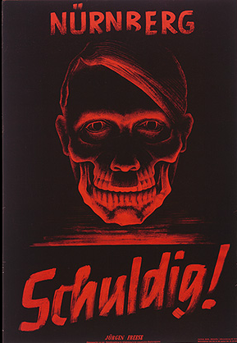 | Poster: Nuremberg / Guilty!  After the end of the war and the defeat of Nazi Germany, Allied occupation authorities in Germany used posters such as this one to emphasize the criminal nature of the Nazi regime.
Part A: What type of persuasion does this propaganda poster use?
- Ethos
- Pathos
- Logos
Part B: What part of the poster best supports the type of persuasion identified in Part A?
- The color red
- “Guilty”
- “Nuremberg”
- The skull
Part C. What technique best supports the persuasive device identified in Part B?
- Card-stacking
- Ad-hominem (name calling)
- Transfer
- Common man

