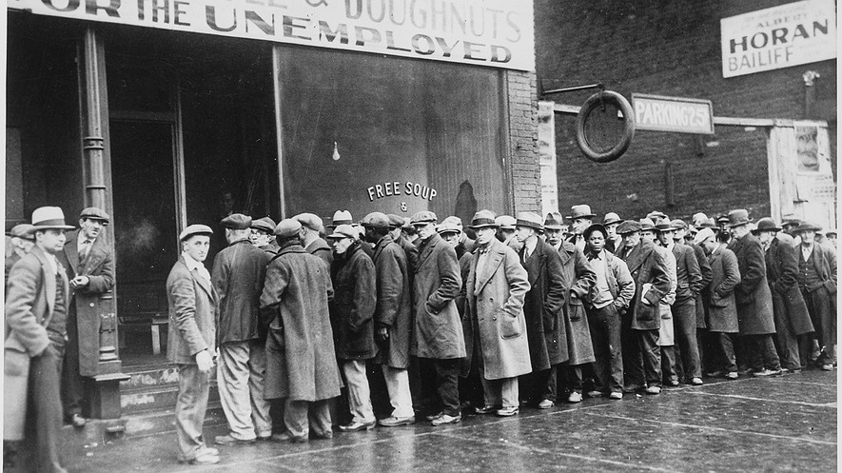
Unemployed men line up outside a Depression soup kitchen in Chicago, Illinois, in 1931. National Archives and Records Administration

The Many Causes of the Great Depression
David M. Kennedy, The Gilder Lehrman Institute of American History, adapted by Newsela staff
Herbert Hoover, the 31st president of the United States, served just one term in office, but it was a memorable one. It was defined by the stock market crash of 1929 and the beginnings of the Great Depression.
Economists and historians continue today to debate the causes of the Great Depression. There is little doubt that there is a link to World War I. The fighting had taken a cruel toll on key economies, like Britain, France and Germany. These countries were the core societies of the advanced industrialized world. Disruptions in trade and the flow of money continued after the war ended. Furthermore, bitter memories of the war left countries feeling at odds with one another, preventing them from forming a unified approach to deal with the frail global economy.
The United States' actions in World War I were minor and only occurred toward the end of the conflict that lasted from July 28, 1914, to November 11, 1918. The country's role went against its tradition of not involving itself in Europe's affairs. This resulted in Americans turning their country even more inward during the 1920s. The United States disarmed its military forces and war machinery. The Senate refused to approve the Treaty of Versailles, which was a peace agreement between Germany and the Allied Powers (predominately Great Britain, France, Russia and Italy) to end World War I.

Turning their backs on the outside world
The Senate also rejected membership in the League of Nations, which was an international organization formed to resolve disputes between countries, even though it had been promoted by former President Woodrow Wilson.
In 1922, Congress passed one of the highest taxes in history on those who sold foreign goods in the U.S., which hurt trading between countries.
Meanwhile, the federal government insisted throughout the 10 years after the war that the Europeans must repay all the loans given to them by the U.S. Treasury. This was a hardship for the countries recovering from war.
In 1924, America, for the first time in its history, imposed a strict limit on the number of immigrants who could annually enter the country. Millions of people were turned away.
Militarily, diplomatically, commercially, financially and morally, Americans seemed to be turning their backs on the outside world.
As the Great Depression began to unfold, a private and dysfunctional banking system made its way into the modern era. It made for an unstable foundation for the national credit. Meanwhile, the government's public spending was low. The federal government was in a weak state to fight the looming depression.

The Great Crash bursts the bubble
In October of 1929, the bubble burst. Known as the Great Crash, stock prices plunged. Thousands of banks failed. Tens of thousands of businesses collapsed. Millions of people became unemployed. Herbert Hoover had been elected president just months earlier. He would forever be known for not being able to save the country from the Great Depression, though he tried.
By 1932, about 13 million Americans were out of work. This equaled 1 out of every 4 workers in the country. Many Americans believed they were witnessing not just a massive market downturn, but the collapse of a historic economic, political and social order. Perhaps this would be the end of the American way of life.
Franklin D. Roosevelt, commonly known as FDR, was elected president in 1932. He promised “a new deal for the American people.” FDR brought with him to the presidency, and the American people, one simple and supremely important belief: that American life could be made more secure. His results transformed American society. FDR held office for more than a dozen years. He was elected president three times, a record unmatched by previous presidents and forbidden for all future presidents when the 22nd Amendment to the Constitution was passed in 1951.
FDR, like Hoover before him, never did find a remedy for the Great Depression. It hung heavily over the land through virtually all of Hoover’s presidency, through FDR’s first two terms, down to 1940 and even beyond. Before World War II came along and revolutionized all political and economic formulas, none of FDR’s exertions managed to drop the unemployment rate below 14 percent.

The New Deal, and war
But FDR's New Deal invented new governmental institutions to bring strength to the shaky banks, stock exchanges and labor. A comprehensive system of unemployment and retirement money to protect laid-off workers and the elderly was enacted. Achieving secure, stable lives for Americans was the main goal of the New Deal’s many programs.
The world the American people tried to shut out after World War I could not be kept at bay, however. Adolf Hitler of Germany came to power within weeks of FDR taking office in 1933.
The entire history of Roosevelt’s presidency unfolded under the shadow of Hitler’s dictatorship and the rising threat of Nazism. The story of the Great Depression is not simply the story of the American people during some of the hardest times in its history. It is also part of a larger story of people in every part of the world who were swept up in the enormous hardships of the Great Depression and, ultimately, World War II.
David M. Kennedy is the Donald J. McLachlan Professor of History at Stanford University. He wrote "Birth Control in America: The Career of Margaret Sanger" (1970) and "Over Here: The First World War and American Society" (1980).

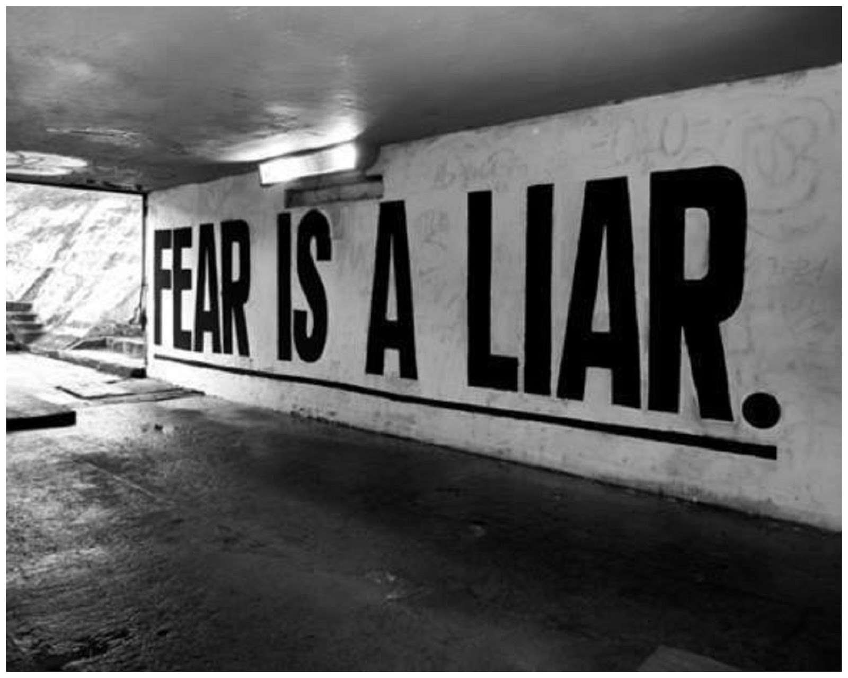

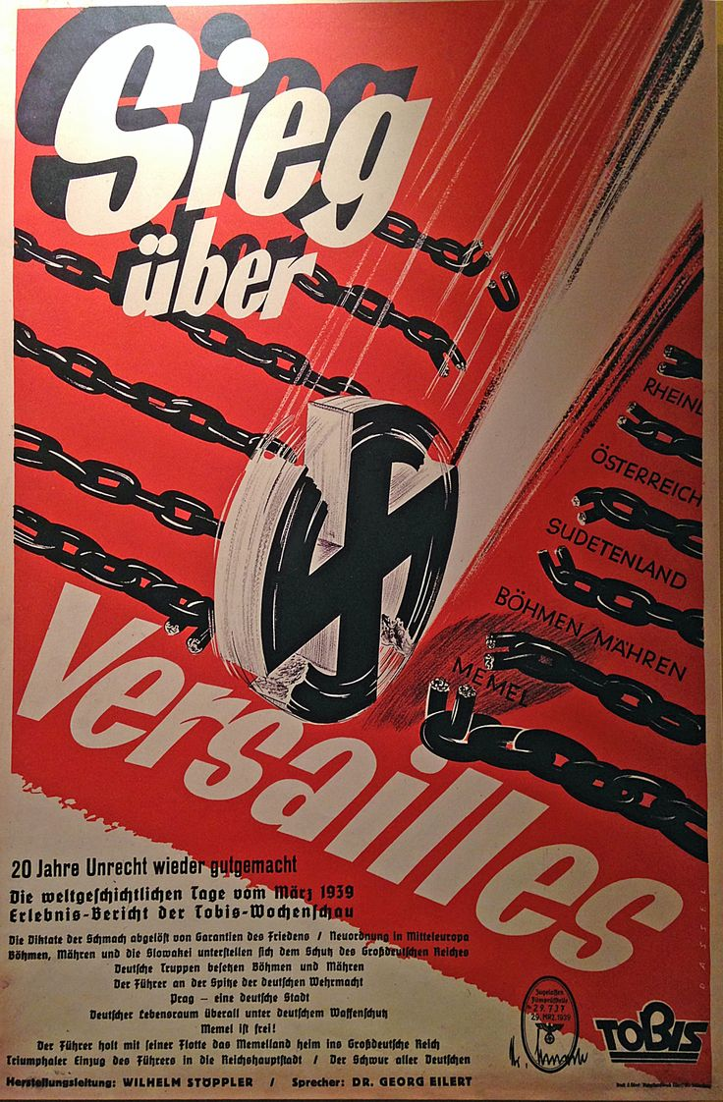

Victory over Versailles (Treaty of Versailles)

