French Revolution
  - See-Think-Wonder
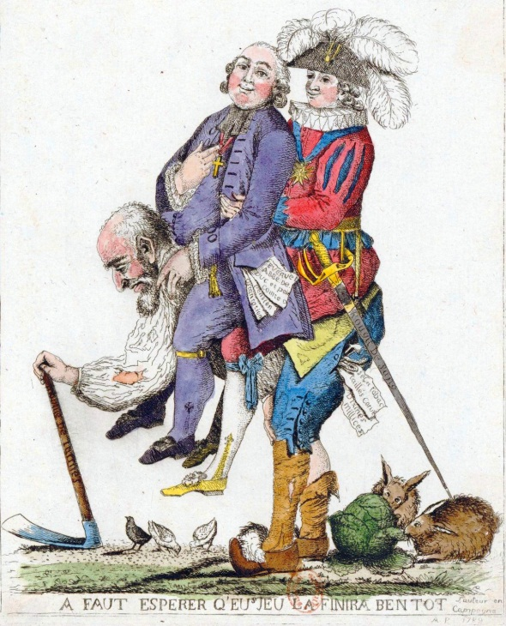
- What do you see?

- What do you think about that?

- What does it make you wonder?

