THE FRENCH REVOLUTION: PHASES AND DATES
Estates General (3 Orders: Clergy, 300 reps.; Nobility, 300 reps.; "Third Estate," 600 reps.)
May 5, 1789: After bad harvests and costly wars, King Louis XVI is forced to convene this ancient assembly in order to raise taxes.
During the election process, voters traditionally draft petitions of grievance (cahiers de doléances)(p.678)

National Assembly (1789-1791)(3rd Estate declares itself the "Assembly of the Nation," June 17, 1789)
June 29, 1789: Tennis Court Oath. Nat. Ass. resolves not to disband until it has written a constitution.
July 14, 1789: Bastille stormed and taken by a Paris mob. (p. 680)
July 19-Aug. 3, 1789: Great Fear. Peasants attack noble manors. (p. 681f)
Aug. 4, 1789: Nobles in National Assembly renounce feudal rights; Jacobin Club formed. (p. 682f)
Aug. 27, 1789: Assembly issues Declaration of the Rights of Man. (pp. 682, 684)
Oct. 5-6, 1789: King Louis brought from Versailles to Tuileries palace in Paris. (p. 683)
July 12, 1790: Assembly issues Civil Constitution of the Clergy, requiring elections and oaths. (683)
June 20-21, 1791: King flees to Austria, is caught at Varennes.
Aug. 27, 1791: Austria and Prussia call for support of French King ("Declaration of Pillnitz")(686).
Sept. 1791: National Assembly issues Constitution; elections are held.

Legislative Assembly (October 1791-August 1792)(Constitutional Government by elected officials)
Apr. 20, 1792: France declares war on Austria and Prussia. (p. 686)
Aug. 10, 1792: Paris mob storms royal palace; Commune siezes Assembly; Legislative Assembly falls. Minister of Justice Danton purges thousands of presumed traitors.
Sept. 20, 1792: French army stops Prussians and Austrians at Valmy (Belgium).

National Convention (Sept. 1792-1795)(elected by universal male suffrage to rewrite constitution)
Sept. 21, 1792: Convention abolishes monarchy and declares France a republic.(p. 687)
Oct. 1792: Revolutionary calendar introduced; Sept. 22, 1792=day 1. (p. 692f)
Jan. 21, 1793: Convention condemns and executes the King. (p. 687)
Feb. 1793: Convention declares war on 1st Coalition of Austria, Prussia, Britain, Holland and Spain.
Feb. 1793: Counter-revolutionary revolt in the Vendee begins. (p. 687)
March 1793: "Reign of Terror" by Committee of Public Safety (Robespierre) begins. (p. 688).
Aug. 23, 1793: Levy-in-Mass (military draft) instituted.
Fall 1793: price controls, dechristianization, administrative reform (p. 690)
Apr. 4, 1794: Danton executed.
June 26, 1794: French victory over Austrians at Fleurus (Belgium).
July 28, 1794: "Thermidor:" Robespierre executed, end of terror. (p. 691)
Feb. 21, 1795: Churches reopened. (p. 694)
Aug. 22, 1795: New constitution is adopted, forming the Directory. (p. 694)

Directory (1795-1799)(New constitution has 2 houses: Council of Ancients and Council of 500)
Oct. 5, 1795: Napoleon's "Whiff of Grapeshot" save the Directory from a royalist mob.
Sept. 4, 1797: Coup d'état removes royalists from Directory.
Oct. 17, 1797: French defeat Austrians in northern Italy and make peace. (p. 696)
1798: French capture Switzerland, Rome and Naples; suffer bad defeat in Egypt (Aug. 1).
Spring 1799: 2nd Coalition of Austria, Russia, Turkey and Great Britain drive French Army back.
Nov. 9, 1799: Napoleon's coup d'état abolishes Directory and establishes Consulate.

Consulate (1799-1804)(Constitution of 1800 has executive of 3 consuls)
1801-2: Napoleon makes peace with Austria and Britain, Concordat with the pope. (p. 697)
1803: Renewed war with Britain.
1804: Napoleonic Code promulgated. (p. 698)

Empire (1804-1815)(Napoleon crowns himself emperor)
1805: 3rd Coalition (Austria, Britain and Russia) moves against France. (p. 699)
1805-09: French victories; "republics" set up throughout Europe, Spain resists.
1812: Napoleon suffers major defeat in Russia (40,000 of 611,000 survive). (p. 701)
1814: Austria, Britain, Prussia and Russia defeat France, Napoleon sent to Elba.
Mar. 1815: Napoleon returns to France for "100 days." (p. 701)
June 18, 1815: British and Prussians defeat Napoleon at Waterloo; Louis 18th restored.

Estates-General of 1789
  - May 1789
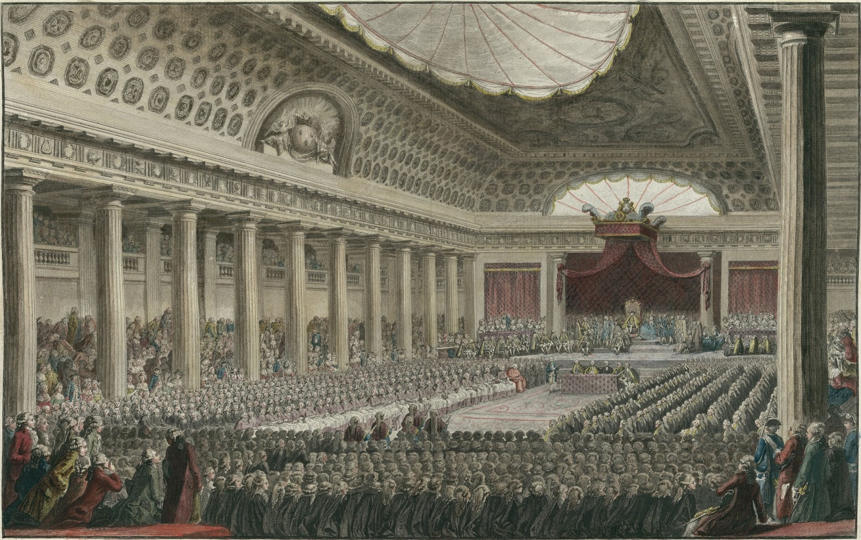
Why did King Louis XVI call the Estates-General?

National Assembly
  - June 1789
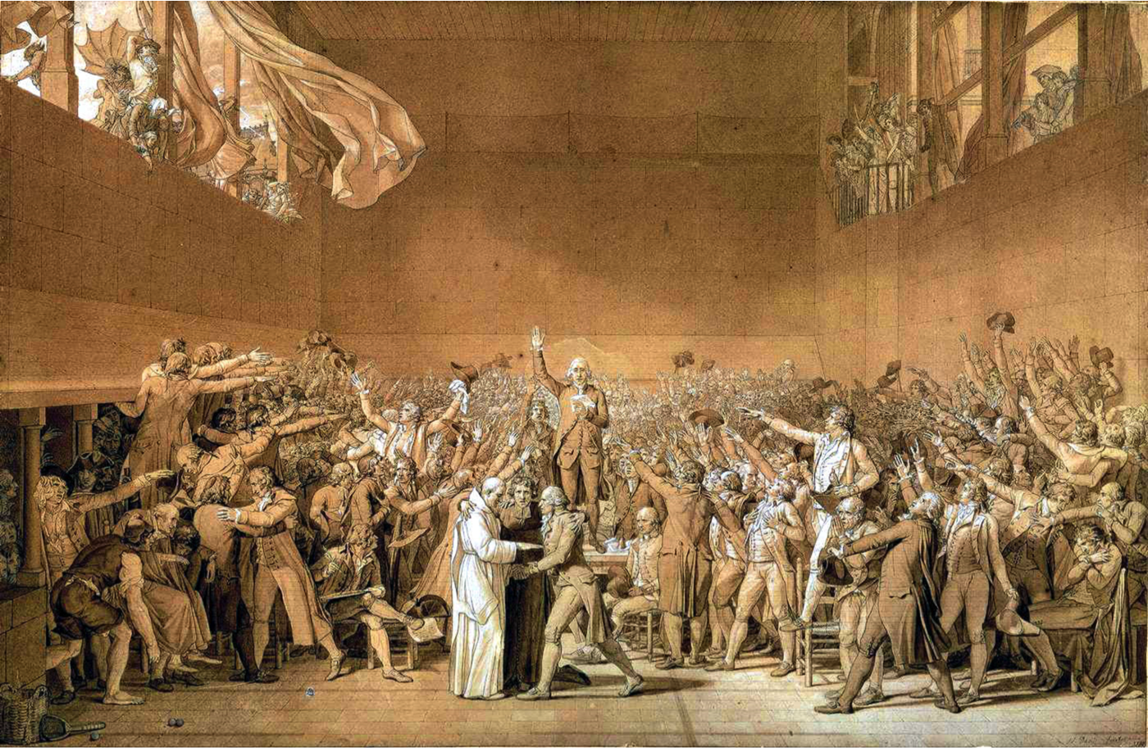
How did the third estate end up in a tennis court? What oath are they making?

Storming the Bastille
  - July 1789
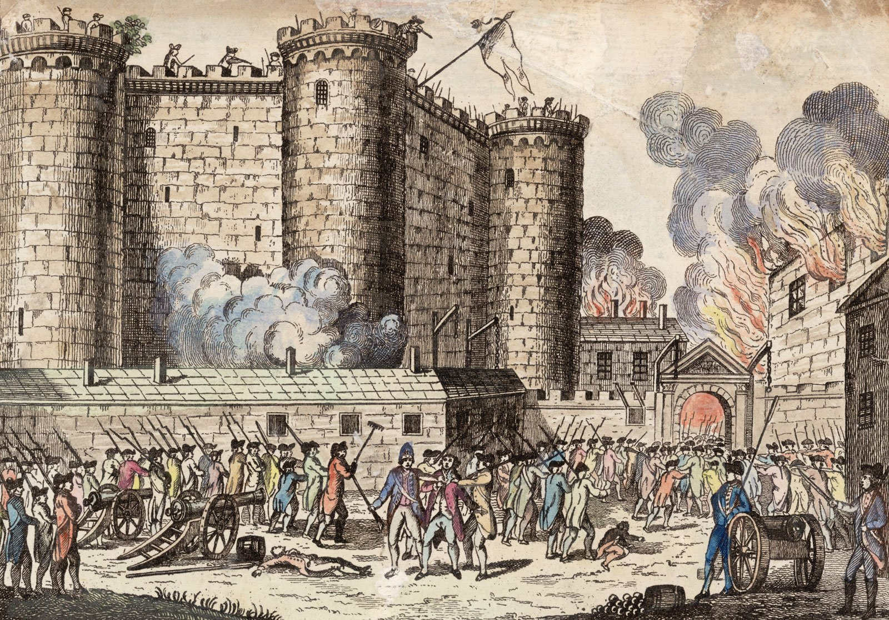
Why were the Parisians storming the Bastille?

The Great Fear
  - July-August 1789
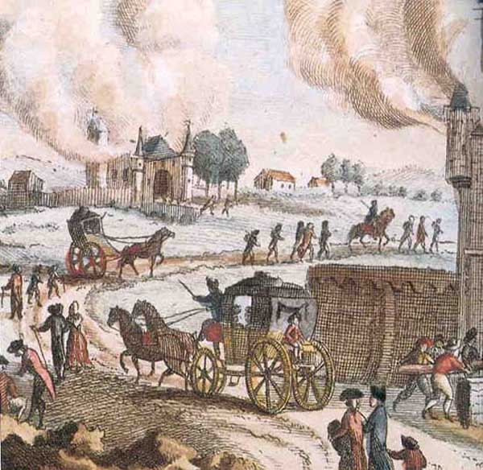
What was the results of the peasants attack on the nobility (the second estate) in the “great fear”?

Declaration of the Rights of Man and of the Citizen
  - August 1789
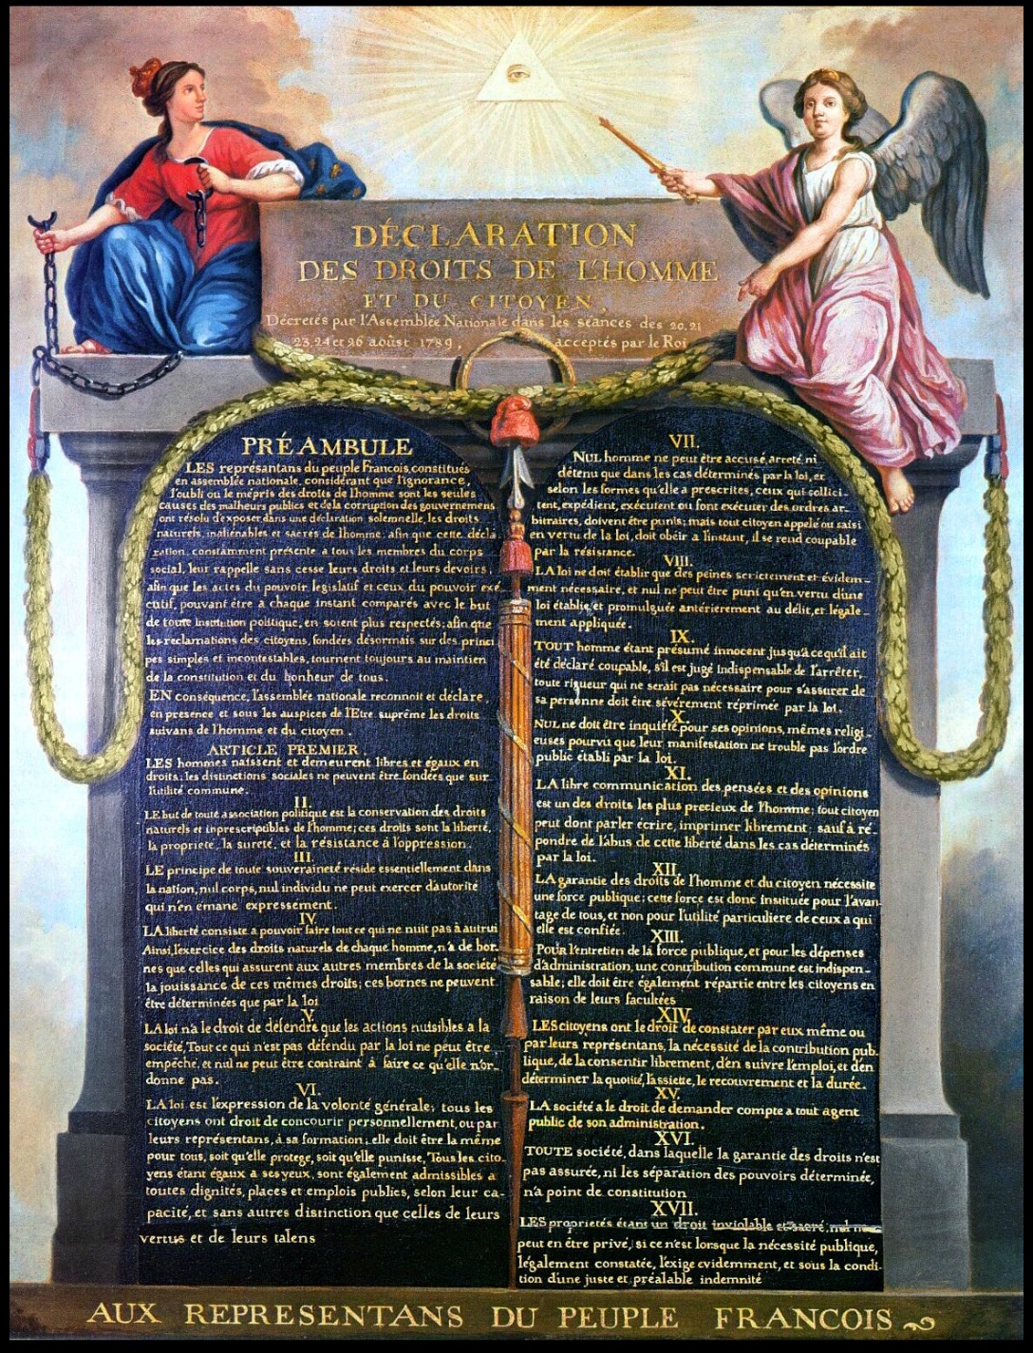
What government was formed after this declaration of rights?

Women's March on Versailles
  - October 1789
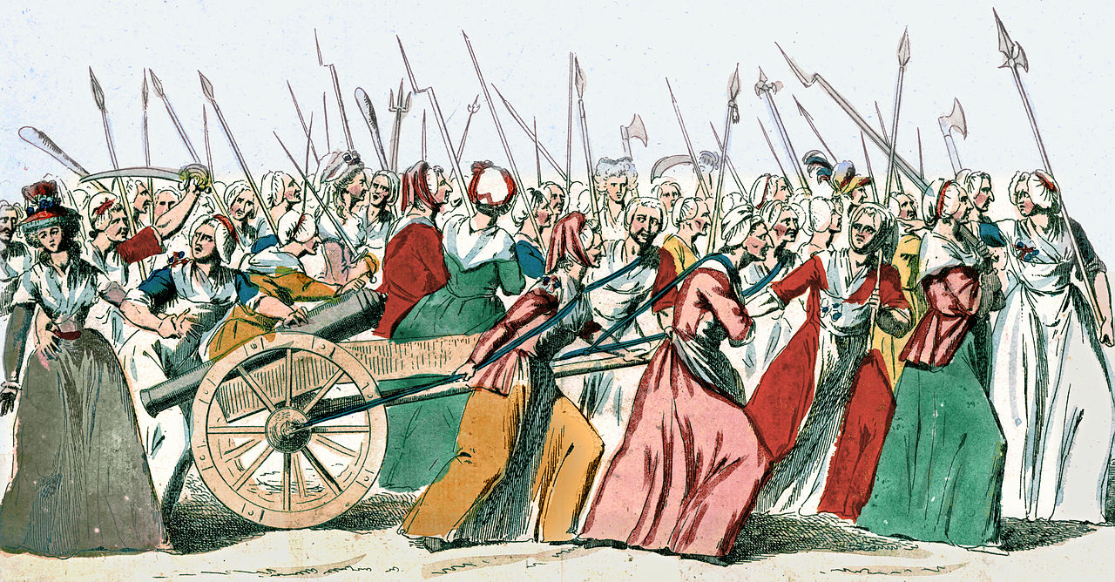
Why did women march on Versailles and what impact did it have?

Civil Constitution of the Clergy
  - July 1790
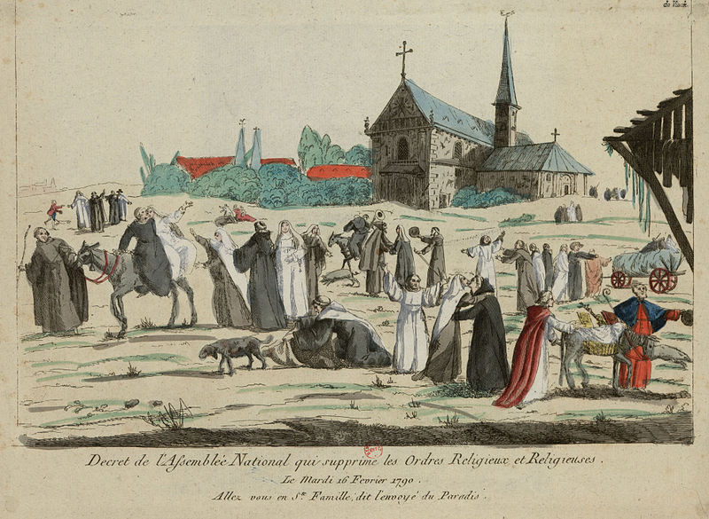
What changes did the clergy (the first estate) face?

Flight to Varennes
  - June 1791
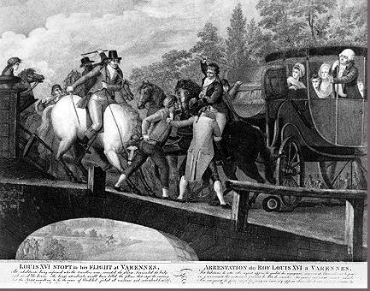
What was the impact of King Louis XVI’s attempt to flee France?

Revolutionary Wars
  - 1792-1802
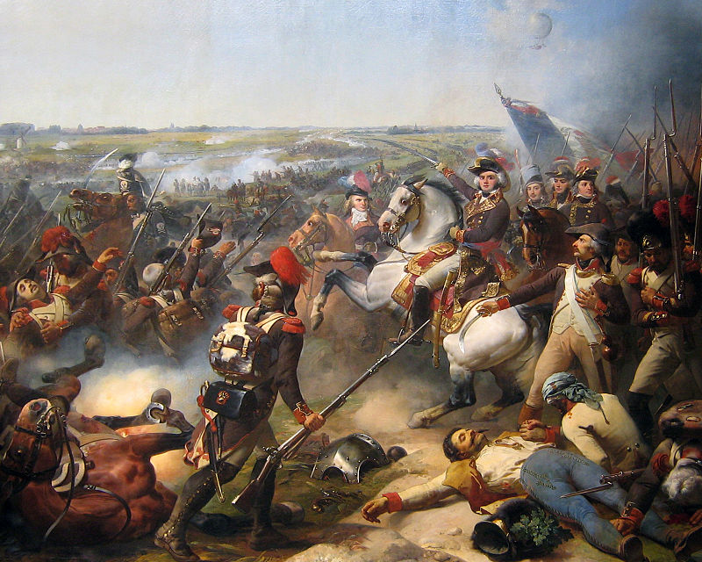
Why was France involved in wars with other countries? Which figure rose as a hero from these wars?

Paris Commune
  - August 1792
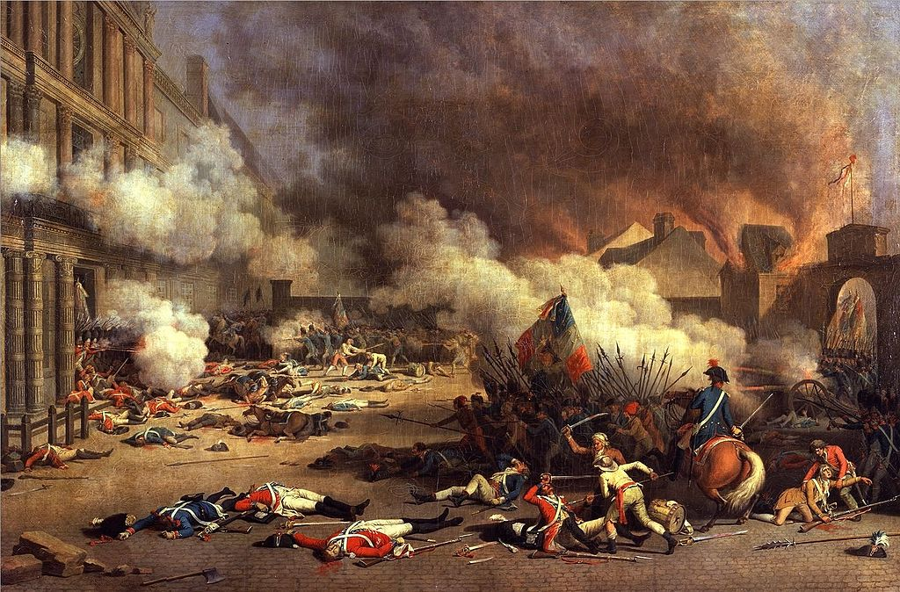
How was the constitution changed after the monarchs were imprisoned after the storming of the Tuileries Palace?

Execution of the King
  - January 1793
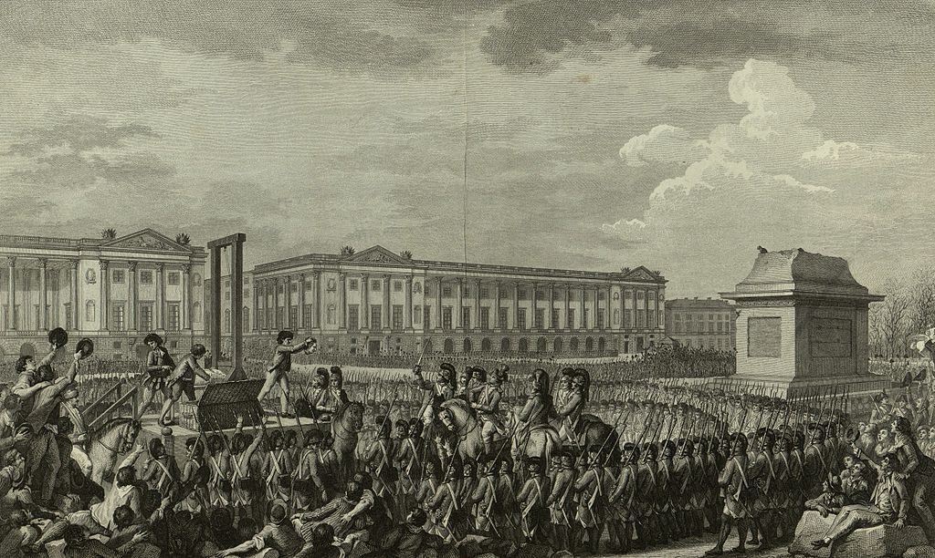
What was the “reign of terror”?

Thermidorian Reaction
  - July 1794
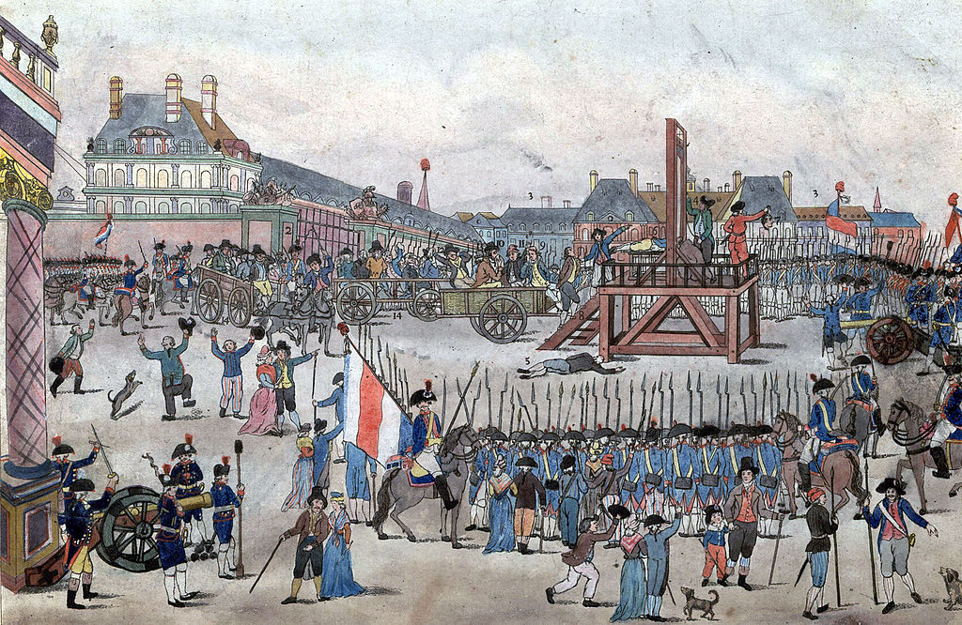
What was the Thermidorion Reaction? What new government was formed?

Napoleonic Code
  - 1804
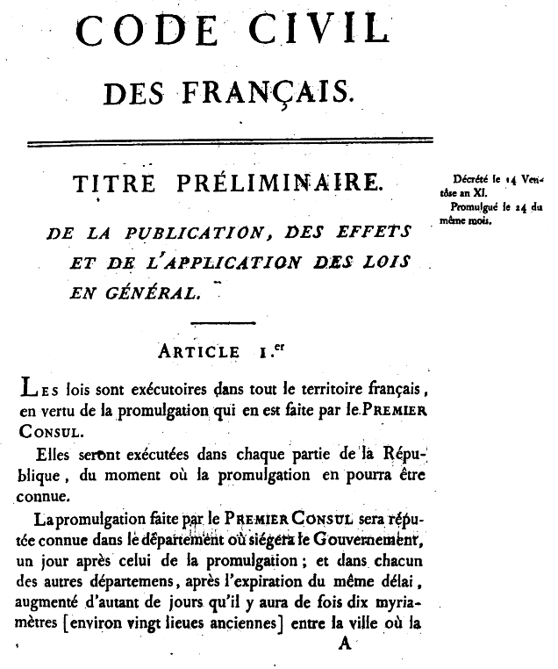
What was the importance of the Napoleonic Code?

Napoleon Bonaparte
  - 1804-15
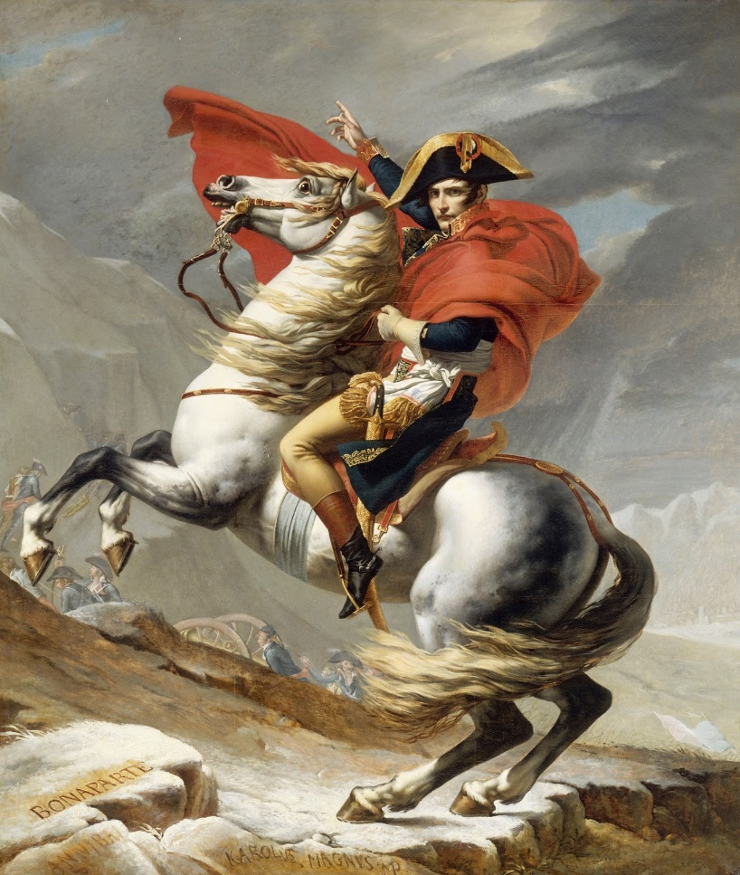
How did Napoleon create an empire? How was he defeated?

French Revolution
Estates-General of 1789  May 1789 | 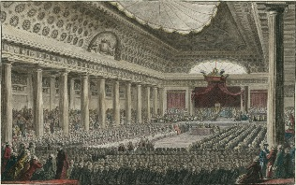 | Why did King Louis XVI call the Estates-General?
National Assembly  June 1789 | 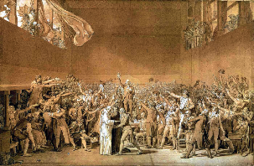 | How did the third estate end up in a tennis court? What oath were they making?
Storming the Bastille  July 1789 | 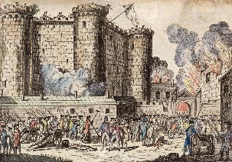 | Why were the Parisians storming the Bastille?
The Great Fear  July-August 1789 | 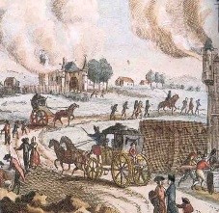 | What was the results of the peasants attack on the nobility (the second estate) in the “great fear”?
Declaration of the Rights of Man and of the Citizen  August 1789 | 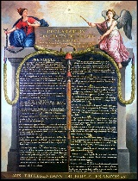 | What government was formed after this declaration of rights?
Women's March on Versailles  October 1789 | 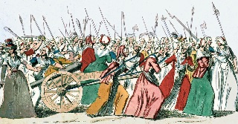 | Why did women march on Versailles and what impact did it have?
Civil Constitution of the Clergy  July 1790 | 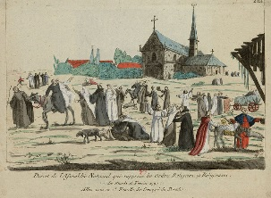 | What changes did the clergy (the first estate) face?

Flight to Varennes  June 1791 | 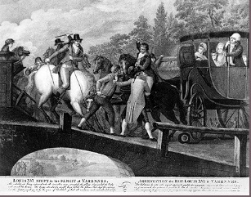 | What was the impact of King Louis XVI’s attempt to flee France?
Revolutionary Wars  1792-1802 | 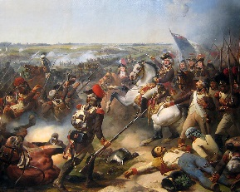 | Why was France involved in wars with other countries? Which figure rose as a hero from these wars?
Paris Commune  August 1792 | 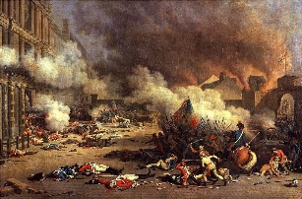 | How was the constitution changed after the monarchs were imprisoned after the storming of the Tuileries Palace?
Execution of the King  January 1793 | 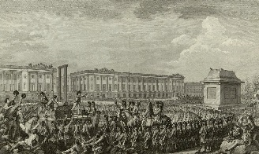 | What was the “reign of terror”?
Thermidorian Reaction  July 1794 | 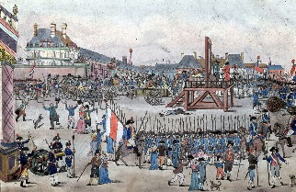 | What was the Thermidorion Reaction? What new government was formed?
Napoleon Bonaparte  1804-15 | 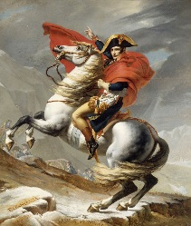 | How did Napoleon create an empire? How was he defeated?
Napoleonic Code  1804 |  | What was the importance of the Napoleonic Code?

French Revolution
Estates-General of 1789  May 1789 |  | Why did King Louis XVI call the Estates-General?  King Louis XVI called together the Estates General, the first legislative meeting since 1614, at Versailles in order to resolve the financial crisis facing the nation after huge debts gathered from the Seven Years War and American Revolution. Representative came from the clergy (first estate), the nobles (second estate) and every else (third estate), though primarily from the middle class or bourgeoisie.
National Assembly  June 1789 |  | How did the third estate end up in a tennis court? What oath were they making?  The Third Estate argued the voting system for the Estates General unfairly advantaged the first two estates, since each estate received one vote rather than by each representative. They therefore called together a National Assembly to represent the nation. When the King locked them out of the assembly, they moved to the tennis court, where they swore to form a constitution.
Storming the Bastille  July 1789 |  | Why were the Parisians storming the Bastille?  Fearing the King was attempting to break up the National Assembly and halt reform, Parisians attacked the Bastille, which was a prison that symbolized the power and abuses of the monarchy. Ultimately the Bastille was destroyed.
The Great Fear  July-August 1789 |  | What was the results of the peasants attack on the nobility (the second estate) in the “great fear”?  Unrest spread into rural areas also, where there was concern about a conspiracy of the aristocracy against the third estate. Drought was already threatening the fall harvest and tensions were high. The countryside attacked manor houses. In response, the National Assembly abolished the feudal regime.
Declaration of the Rights of Man and of the Citizen  August 1789 |  | What government was formed after this declaration of rights?  Similar to the American Declaration of Independence, the Declaration of the Right of Man set down principles, especially by ending privileges of the first and second estates. The Constitution of 1791 formed a constitutional monarchy.
Women’s March on Versailles  October 1789 |  | Why do women march on Versailles and what impact did it have?  Despite the political changes, little had been done to alleviate the financial problems. People continued to face high prices and food shortages. Women appropriated weapons from an armory and then marched to the King in Versailles to make their concerns heard. The king was forced to return to Paris and demonstrated the growing power of the common people.
Civil Constitution of the Clergy  July 1790 |  | What changes did the clergy (the first estate) face?  The National Assembly took the privileges of the tithe and land, but thereby took on the responsibility of paying the clergy and caring for the poor. The clergy became employees of the state and were required to take an oath of loyalty, which many resisted as in conflict with their ties to the pope.

Flight to Varennes  June 1791 | 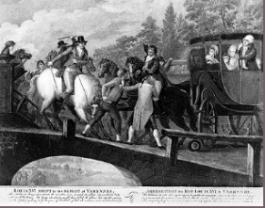 | What was the impact of King Louis XVI’s attempt to flee France?  The king unhappy with the direction of the revolution decided to flee Paris, but was recognized and brought back. The king lost credibility and further pushed the Assembly toward limiting his power in the Constitution of 1791.
Revolutionary Wars  1792-1802 |  | Why was France involved in wars with other countries? Which figure rose as a hero from these wars?  As other nations witnessed the events of the French Revolution, their monarchies began to insist that King Louis be returned to power. France fearing Austria would attempt to reinstate Louis attacked Austria. European monarchs fear increased with the execution of the king and wars continued throughout the period. Napoleon Bonaparte would ultimately defeat their enemies and expand French borders.
Paris Commune  August 1792 |  | How was the constitution changed after the monarchs were imprisoned after the storming of the Tuileries Palace?  Despite the new government a crisis was escalating—the king refused limitations, concern about decisions against the church, continuing financial problems, taxation, resentments, and threats from outside. After the imprisonment of the king pressure mounted for greater change—universal male suffrage and abolishment of the monarchy—and in September a republic was formed.
Execution of the King  January 1793 |  | What was the “reign of terror”?  After the beheading of the king by the republic, the direction of the France was fought between the radical Jacobins who saw themselves as defenders of the people’s will and the moderate Girondists who were felt that the revolution had gone far enough. Jacobins increasingly dominated and began to crush opposition at home and abroad. Led by Maximillian Robespierre, about 17,000 were sent to the guillotine
Thermidorian Reaction  July 1794 |  | What was the Thermidorion Reaction? What new government was formed?  Maximillian Robespierre was eventually arrested and executed, bringing the Girondists to power. They formed a new constitution with executive power in a five member Directory. It removed universal male suffrage and made it dependent on property again.
Napoleon Bonaparte  1804-15 |  | How did Napoleon create an empire? How was he defeated?  Napolean rose to power through a coup de ’tat that brought the weak and corrupt Directory to end. He quickly set up a dictatorship and brought stability to France. He also built a strong army that he used to conquer much of Europe. He was defeated in Russia and forced into exile. Within a year he was back and at war, but was finally defeated by British and Prussian forces at Waterloo. He died in exile on the island of Saint Helena.
Napoleonic Code  1804 |  | What was the importance of the Napoleonic Code?  He rewrote the laws of France along the principles of the Enlightenment, that is, according to the idea of natural law. It made all men equal before the law and established freedom of religion. Nevertheless, those laws curtailed many rights of individuals. These laws influenced the regions Napoleon had conquered and weakened the old regime of power among the monarchy, nobles and clergy.

